**CHAPTER 1**

# INTRODUCTION

This section provides the outline and brief discussion of the proposed system. It narrows down the history of co-working space institution, addresses the problem’s context, and discusses why the project should be implemented. The said chapter also explains the detailed description of the project’s goals and objectives.

## **Project Context**

The fast growth of work and education in recent years has fundamentally altered how individuals use physical places for productivity. The growing popularity of remote work, freelancing, startup culture, and hybrid learning methods has resulted in an increased need for flexible, well-equipped, and easily accessible coworking spaces. Professionals, entrepreneurs, and students who need a safe environment to communicate, focus, and develop no longer have to limit themselves to traditional office settings. However, the current system of co-working space bookings frequently has inefficiencies and problems that prevent seamless utilization.

A co-working station is a contemporary, shared working environment that serves a wide range of users, including freelancers, remote workers, students, corporate teams, and entrepreneurs. It is especially designed to provide a flexible, functional, and professional environment in which people or groups may work, meet, or collaborate without the long-term commitment or expense associated with typical office arrangements. Unlike traditional offices, co-workspace stations emphasize shared usage and on-demand accessibility, making them perfect for today's mobile and hybrid workforce. These spaces generally have a range of physical configurations to fit diverse purposes, such as private offices for concentrated work, open workstations for solo workers, and conference rooms for meetings or team discussions. They are also outfitted with smart access control systems, such as QR codes, to guarantee that only authorized users may enter and use the facilities, which improves both security and user comfort. These spaces generally have a range of physical configurations to fit diverse purposes, such as private offices for concentrated work, open workstations for solo workers, and conference rooms for meetings or team discussions. They are also outfitted with smart access control systems, such as QRcodes, to guarantee that only authorized users may enter and use the facilities, which improves both security and user comfort.

A co-workspace station typically offers a range of amenities such as high-speed internet, desks or hot-desking options, meeting rooms, private offices, communal areas, and sometimes refreshments like coffee and snacks. Unlike conventional office setups that often tie businesses to long-term leases, coworking spaces are more cost-effective and flexible, allowing users to rent space on a daily, weekly, or monthly basis depending on their needs.

Co-working stations are shared workspaces designed to provide professionals, freelancers, startups, and remote workers with a productive and flexible environment. These spaces are typically equipped with office essentials such as desks, high-speed internet, meeting rooms, printing services, and communal areas. What sets co-working stations apart is their emphasis on collaboration and community, allowing individuals   
from various fields to work in the same space, share ideas, and form connections. This setup encourages networking and innovation, making it a popular choice for creative professionals and small businesses looking for affordable and dynamic alternatives to traditional office rentals.

In today's rapidly evolving work environment, flexibility and accessibility are becoming essential for professionals, entrepreneurs, and businesses. The rise of remote work, driven by technological advancements and changing workforce preferences, has made coworking spaces a popular solution. These flexible workspaces provide an affordable, dynamic, and collaborative environment for individuals and teams, enabling them to work productively without the constraints of traditional office setups.

Despite this growth, the traditional office market faces challenges, with office vacancy rates in Metro Manila reaching a record high of 19.8% in 2024, partly due to the exit of Philippine offshore gaming operators (POGOs). International Workplace Group (IWG), a leading coworking space provider, reports maintaining a minimum occupancy rate of 85% monthly over the past 18 months, indicating strong and consistent demand. Additionally, the 2023 Asia Pacific Workforce Hopes and Fears Survey revealed that 51% of Filipino respondents prefer a hybrid work model, reflecting the shift towards flexible workspace solutions. Looking ahead, it is anticipated that by 2030, 30% of corporate real estate in the Philippines will comprise flexible workspaces, underscoring the long-term shift in workplace preferences.

In the Philippines, the demand for coworking spaces has steadily grown, with approximately 548 coworking spaces nationwide as of 2025. Metro Manila remains the primary hub for these spaces, hosting around 232 coworking spaces, which accounts for approximately 42.34% of the national total. This figure represents a 6.70% increase from 2023. Of these locations, 151 coworking spaces (65.09%) are single-owner operations, while the remaining 81 (34.91%) are part of larger brands. The average age of coworking spaces in Metro Manila is 4 years and 5 months. In terms of digital presence, 68 coworking spaces in Metro Manila have LinkedIn profiles, 112 have Facebook Pages, 82 are active on Instagram, 40 maintain X (formerly Twitter) handles, 17 are on TikTok, and 15 have YouTube channels. About 156 coworking spaces have their own website, while the remaining 76 do not.

CALABARZON (Cavite, Laguna, Batangas, Rizal, and Quezon) has approximately 66 coworking spaces, representing about 12.04% of the country's total. Within CALABARZON, Batangas Province has at least 7 coworking spaces, making up around 1.28% of the national count.

Specifically, Batangas Province has emerged as a promising area for coworking spaces, with notable hubs such as The Playground PH, Blanco Spazio, etc. These coworking spaces offer a variety of amenities, including high-speed internet, meeting rooms, collaborative areas, and private offices, catering to freelancers, small businesses, startups, and remote workers. The presence of these spaces supports the province's economic growth by providing local entrepreneurs and professionals with affordable workspaces, fostering innovation, and encouraging networking.

Based on the responses of 50 participants who were the co-owner space owners, office workers and students who used co working space, the survey results clearly indicate that this is a significant problem affecting the community. Firstly, infrastructure and facilities present ongoing issues. Unreliable internet connectivity, even with multiple providers, frequently disrupts client activities. Power interruptions are another persistent problem, and while some spaces attempt to mitigate this with solar backups, the solution is often insufficient. Moreover, the lack of private work areas in open floor plans can lead to noise disruptions, making it difficult for clients who need a quiet space. Maintenance is another concern, with most spaces relying on manual tracking, which increases the likelihood of missed tasks and inconsistent upkeep. Secondly, client experience and satisfaction are impacted by various factors. Noise control is a common complaint due to open layouts. Miscommunication of space policies is another issue, as lenient rules can lead to misunderstandings. Retaining clients is also a challenge, with limited incentives for long-term use and a lack of structured loyalty programs. Client feedback is often collected informally through social media, missing opportunities for systematic improvements.

Moreover, booking management is another problematic area. Clients may be confused about booking methods, whether online or walk-in. The reliance on manual booking processes can lead to overbooking or double booking, and there is no automated system to manage booking disputes, making conflict resolution difficult. Pricing and affordability also pose challenges. While discounts are available, there is limited pricing flexibility, and clients may feel they are not receiving adequate value due to frequent internet and power issues.

Additionally, maintenance and safety management are often inconsistent. Manual maintenance tracking increases the risk of missed tasks, and maintaining consistent cleanliness can be difficult without automated systems. Security measures are typically basic, relying on client discipline rather than robust protocols. Customer service also varies depending on individual staff members, with no standardized protocol for handling clients. Client records and feedback are managed manually, which limits the ability to scale effectively.

Community engagement within co-working spaces can be weak. While some spaces host events, these may not be enough to foster strong client relationships. Moreover, without a system to personalize client interactions, many clients may feel disconnected. Finally, sustainability and resource management remain a concern. Despite the presence of solar power, energy management is not fully optimized, and resource utilization is rarely tracked, leading to potential wastage. FlexiDesk aims to address these challenges through automation, enhanced client management, improved feedback collection, efficient maintenance tracking, and a superior client experience.

**Purpose and Description**

The primary purpose of this study is to design and develop an innovative web-based system. In recent years, the landscape of workspaces has   
significantly transformed, largely due to the global shift toward remote work,   
freelancing, and the gig economy. Traditional office settings are increasingly giving way to flexible and dynamic co-working environments that cater to professionals who value accessibility, affordability, and collaboration. However, the rapid expansion of co-working spaces has also brought about logistical challenges in managing desk allocations, scheduling meeting rooms, and ensuring optimal space utilization. This study aims to address these challenges through a smart, automated, and user-friendly solution.

FlexiDesk is envisioned as a comprehensive platform that empowers users to easily locate, reserve, and manage their workspace needs from any device with internet access. The system will provide real-time updates on desk availability, allow users to filter options based on specific needs (such as amenities, room size, or proximity), and streamline the booking process. For co-working space administrators, the platform will offer tools to monitor occupancy, analyze usage trends, and manage user bookings efficiently. The overarching purpose is to enhance the experience of both users and providers by reducing manual intervention, eliminating double bookings, and promoting a smarter allocation of shared resources.

Additionally, the study serves to contribute to the broader field of smart workplace technologies. It explores how web applications can be harnessed to solve real-world logistical problems in collaborative work environments. By developing FlexiDesk, this project not only responds to a growing market demand but also advances the integration of technology into space management solutions. The research and development process also aims to identify best practices in user interface design, system architecture, and data handling for scalable and secure web applications. Ultimately, the goal is to foster a smarter, more connected workspace ecosystem that adapts to modern work habits and technological advancements.

FlexiDesk is a smart, web-based application tailored to meet the evolving needs of modern co-working environments. The platform functions as an intelligent workspace management tool, designed to make the process of tracking and booking desks or rooms in shared office spaces more efficient, transparent, and user-friendly. The web application is intended to serve two main types of users: the workspace users (freelancers, remote workers, startups, etc.) and the co-working space providers or administrators.

For users, FlexiDesk offers a seamless experience in finding and reserving available workspaces. The platform includes features such as an interactive floor map to view desk availability in real time, filtering options to select workspaces based on desired features (e.g., high-speed internet, conference facilities, natural lighting), and a secure booking system that confirms reservations instantly. Users can also manage their bookings, receive reminders, and make modifications through their personal dashboards. The application supports user authentication and profile management, ensuring personalized experiences and security.

For administrators, FlexiDesk acts as a centralized management system. It provides tools to track real-time occupancy, forecast demand patterns, manage subscriptions or payment plans, and generate reports on space utilization. The system is designed with scalability in mind, making it suitable for small co-working hubs as well as large multi-location providers. It also supports role-based access control to differentiate between regular users, administrative staff, and system managers.

The study involves the complete lifecycle of software development, starting from requirements gathering, system design, prototyping, and implementation, to testing and evaluation. Emphasis is placed on responsive design, so the platform remains functional and accessible across devices, including desktops, tablets, and smartphones. Technologies such as cloud-based databases, interactive JavaScript frameworks, and API integrations are employed to ensure performance, security, and extensibility.

This study highlights how digital transformation can enhance physical infrastructure and user experiences in shared environments. By automating manual processes and providing data-driven insights, FlexiDesk represents a step forward in the evolution of smart office technologies. It reflects the ongoing shift in work culture, where flexibility, convenience, and smart solutions are key to productivity and satisfaction. The application not only addresses current pain points but is also built with adaptability in mind, ensuring it remains relevant in the face of future trends in workspace innovation

## **Objectives of the Stud****y**

The major goal of this capstone project is to create FlexiDesk, a smart co-working space monitoring and booking system that provides effective space usage, safe transactions, and data-driven insights for both workspace providers and users.

1. Provide a module for the clients/customers wherein the following can be performed:
   1. Browse and filter spaces based on location, amenities, availability, and pricing.
   2. View workspace details, images, and reviews before booking.
   3. Get AI-driven workspace recommendations based on past bookings and preferences.
   4. Enable users to store favorite venues, set preferences, and receive updates about deals and new listings.
   5. Access co-working spaces via QR code
   6. Pay using credit/debit cards, mobile wallets (PayPal, GCash), or PayMongo/
   7. Use in-app chat to connect with workspace providers.
   8. Get real-time notifications about forthcoming bookings, promotions, and workplace updates.
   9. Submit reviews and ratings to enhance service quality.
   10. Provide customer service and chatbot help with any questions or difficulties.
   11. Enhance or cancel bookings according to the platform's cancelation policy.
   12. Make a request for refunds depending on qualifying criteria, follow their refund status via the platform, and submit any necessary data or documents for processing.
2. Provide a comprehensive module for workspace owners to efficiently manage listings, bookings, customer engagement, and earnings.
   1. List and manage various workspace types such as private offices, dedicated desks, hot desks, and meeting rooms.
   2. Customize workspace details including descriptions, images, amenities, availability schedules, and capacity.
   3. Set dynamic pricing rules based on demand, time slots, day of the week, or seasonal trends.
   4. Launch targeted promotions, discounts, and referral incentives to attract and retain clients.
   5. Accept secure digital payments with automated commission deduction and direct payout to connected accounts.
   6. Access a financial dashboard to track earnings, occupancy rates, peak hours, and performance analytics.
   7. Enable smart access controls like QR code or password authentication for verified bookings.
   8. Engage with clients through in-app chat for inquiries, special requests, or clarifications.
   9. Receive and respond to user reviews and ratings to build trust and improve service quality.
   10. Analyze customer booking behavior and trends to optimize workspace offerings.
   11. Set cancellation, refund, and rescheduling policies tailored to business preferences.
   12. Receive notifications on new bookings, payment status, customer messages, and platform updates.
3. Provide administrators with a centralized platform to oversee user verification, platform integrity, security compliance, and performance optimization.
   1. Verify users and workspace providers to ensure secure onboarding and prevent fraudulent activities.
   2. Monitor workspace performance through analytics such as occupancy rates, peak usage times, and income reports.
   3. Promote high-performing and high-demand workspaces through featured listings and targeted marketing.
   4. Enforce data security using encryption and access control while ensuring compliance with platform policies.
   5. Manage disputes, refund requests, and policy violations to maintain platform trust and reliability.
4. System intelligence is improved by the following AI Features module:
   1. An AI-powered dynamic pricing system suggests prices according to demand, time, and market trends to ensure fair and competitive pricing.
   2. Queue optimization notifies users when spaces are likely to become available, minimizing idle time and increasing use.
   3. Azure AI detects questionable reservations and fraudulent reviews, ensuring platform security.
   4. Immediate Workspace Booking Mode optimizes last-minute or emergency reservations and alerts the appropriate suppliers.
5. Leverage data analytics to drive business insights, optimize operations, and support strategic decision-making.
   1. Descriptive Analytics – Track workspace occupancy, booking trends, customer demographics, payment flows, cancellation and refund patterns, and overall user engagement across searches, reservations, and reviews.
   2. Predictive Analytics – Forecast peak usage periods and seasonal demand trends to support smarter pricing and availability planning.
   3. Prescriptive Analytics – Recommend data-driven pricing strategies, ideal booking windows, marketing approaches, and provide AI-powered insights to guide workspace owners in expansion planning and maintenance scheduling.
6. To test and evaluate the develop system using
   1. Test Cases
   2. ISO/IEC 25010 2011 software evaluation criteria in terms of:
      1. Functionality Suitability
      2. Performance Efficiency
      3. Reliability
      4. Usability

## **Scope and Limitations of the Study**

This study focuses on the design, development, and implementation of FlexiDesk, a smart web application intended for managing bookings and tracking   
workspace availability in co-working environments. The scope includes building a functional web-based system with features such as user registration and login, workspace filtering and booking, interactive floor plans, administrative dashboards, and basic reporting tools. The application is targeted primarily at urban co-working spaces that cater to freelancers, remote employees, startups, and small teams.

The study encompasses both the front-end and back-end development aspects of the web application. It incorporates usability testing to ensure the platform is accessible and user-friendly, and it evaluates the system’s performance in terms of responsiveness, accuracy, and scalability. Technologies employed include standard web development stacks (HTML, CSS, JavaScript, and a back-end framework like Node.js or Django), as well as cloud-based storage and database solutions. The system will also be tested in a simulated environment to ensure core features function as expected.

However, the study has several limitations, application is limited to web browsers and does not include a native mobile app version, though it will be mobile-responsive, initial deployment will focus on English-language support and may not be immediately adaptable to multilingual environments.

Lastly, the system’s performance and scalability will be tested under controlled conditions and may differ in real-world environments with larger datasets or more complex infrastructure. These limitations are acknowledged, and future work may explore broader integration with hardware systems, expanded language support, and the development of mobile-native applications to extend the system’s reach.

**Definition of Terms**

This section is built on providing concise and context-specific definitions for essential terms. Through this brief analysis of crucial vocabulary, the proponents hope to give a consistent framework that promotes comprehension, stimulates critical thinking, and strengthens the bond with the upcoming revelations.

**API Integration.** Connecting different software systems using APIs to enable data sharing and seamless functionality. Technologies such as cloud-based databases, interactive JavaScript frameworks, and API integrations are employed to ensure performance, security, and extensibility of the platform.

**Dynamic Pricing.** A pricing strategy where prices fluctuate based on demand and other factors in real time. The platform also offers AI-driven strategies, allowing workspace providers to implement dynamic pricing based on demand.

**FlexiDesk.**A smart co-working space platform that enables users to discover, book, and access flexible workspaces with features such as AI-driven recommendations, digital payments, real-time availability, and smart access control.  
 **Hot-desking.** A flexible office system where employees share desks, choosing available spaces each day. A co-working station typically offers a range of amenities such as high-speed internet, desks or hot-desking options, meeting rooms, private offices, communal areas, and sometimes refreshments like coffee and snacks.

**Role-based Access Control.** A security method where user access is based on their assigned role within an organization. The system is designed with scalability in mind, making it suitable for small co-working hubs as well as large multi-location providers. It also supports role-based access control to differentiate between regular users, administrative staff, and system managers.

**Smart Access Control.** A system that uses technology like mobile apps to manage secure entry to spaces. These spaces are also outfitted with smart access control systems, such as QR codes, to guarantee that only authorized users may enter and use the facilities, which improves both security and user comfort.

**Tracking Devices.**Internet-connected devices that monitor and track the status or location of objects in real time. A workplace may use tracking devices to monitor occupancy in real-time, ensuring efficient space management and accurate availability status.

**CHAPTER 2**

# REVIEW OF RELATED SYSTEMS

In this chapter, the technical background and related systems are shown. It includes the software process that is used throughout the development of the system.

## **Technical Background**

The development of FlexiDesk is rooted in several key technological concepts and methodologies that collectively support the creation of a smart, efficient, and user-friendly co-working space management system. As flexible and hybrid work arrangements become more common, co-working environments are becoming increasingly complex to manage. FlexiDesk is designed to respond to this shift by using smart technologies and digital strategies to address issues such as inefficient space utilization, manual booking conflicts, and lack of real-time workspace visibility.

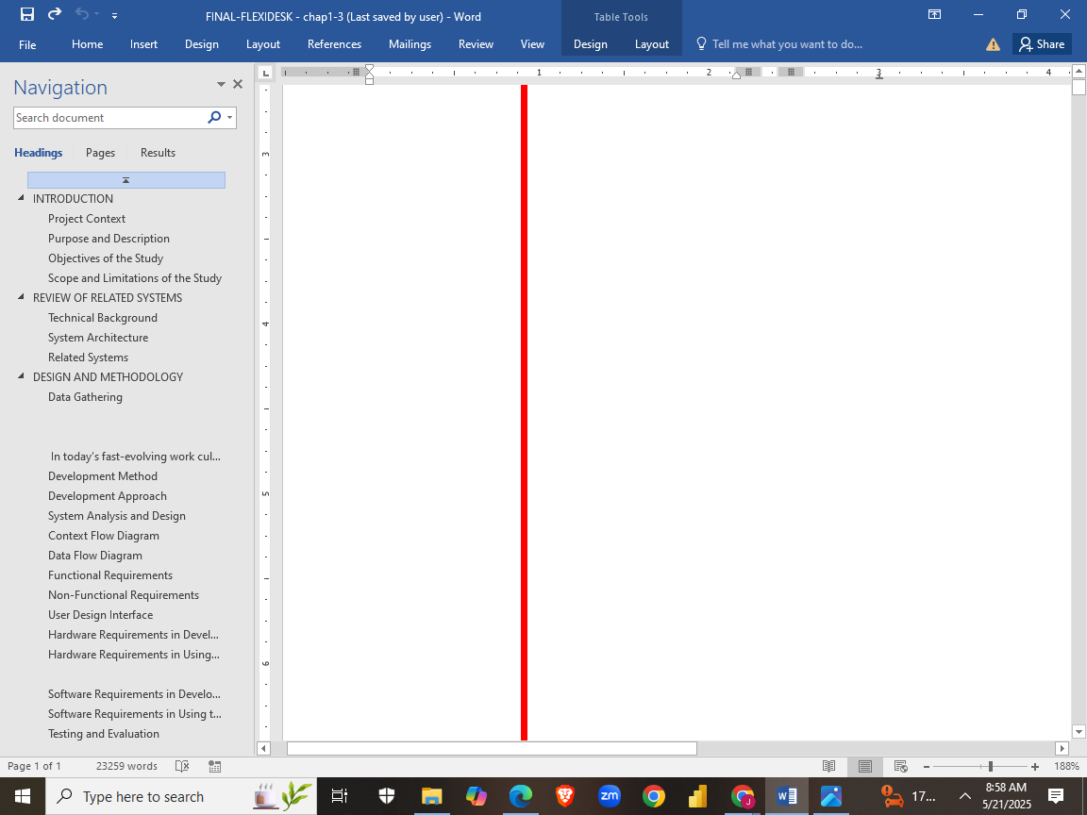One of the central concepts that will applied in FlexiDesk is web-based system architecture. This means the entire application runs on a browser and does not require users to download or install any software. This approach ensures easy access and widespread compatibility, as users can log in from any device with internet access—whether it’s a laptop, tablet, or smartphone. The decision to build a web-based platform enhances both usability and scalability, allowing the system to support small co-working hubs or expand to multi-location office networks with minimal infrastructure changes.

A major feature of FlexiDesk is hot-desking, which is the practice of allowing users to reserve any available desk rather than assigning a fixed desk to a single person. This concept is widely used in modern office setups to promote flexibility and reduce wasted space. Technically, this requires real-time data management, as the system needs to accurately display desk availability and prevent double bookings. FlexiDesk will achieve this by maintaining an up-to-date database that tracks desk status and user reservations dynamically.

Another important concept incorporated in the project is role-based access control (RBAC). In simple terms, this means that users are assigned different levels of access depending on their role in the system. For example, a general user can book desks and view schedules, but only an administrator can add new workspaces or generate occupancy reports. This methodology not only improves system security by limiting access to sensitive data and functions, but it also streamlines operations by giving users only the tools they need.

To improve booking efficiency and revenue potential for workspace providers, FlexiDesk introduces the idea of dynamic pricing. This concept allows the system to adjust booking fees based on different conditions such as peak hours, high-demand areas, or repeat usage. Much like how ride-sharing apps increase fares during rush hour, dynamic pricing in FlexiDesk ensures better demand distribution and maximizes the use of available spaces.

FlexiDesk also considers smart access control, a feature designed to automate and secure entry into reserved workspaces. This can be implemented using technologies such as QR code check-ins, NFC tags, or mobile-based authentication. The idea is to ensure that only the person who booked the desk can access it, preventing misuse and unauthorized entry. This adds a layer of convenience for users and reduces the need for physical keys or manual supervision.

Azure AI can play a crucial role in enhancing functionality, security, and user experience. The integration of Azure AI can provide intelligent features that go beyond basic booking and tracking capabilities, making the system smarter and more efficient.

The use of Azure AI in FLEXIDESK is in fraud detection and user behavior analysis. By analyzing patterns in user bookings, logins, and transactions using Azure Machine Learning and Anomaly Detector, the system can detect suspicious activity such as fake bookings, multiple accounts from the same user, or unauthorized access. This helps maintain the integrity of the platform and protects both workspace providers and customers. Additionally, Azure AI's Cognitive Services can improve the user experience through features like natural language processing (NLP) for chatbot assistants, allowing users to interact with the system using conversational language.

To enable third-party services such as online payments, calendars, and location mapping, FlexiDesk wil support API integrations. An API, or Application Programming Interface, allows different software systems to talk to each other. By using APIs, the application can connect with trusted services like PayPal for payments, Google Maps for location display, or Google Calendar for syncing bookings. These integrations expand the functionality of FlexiDesk without the need to reinvent existing tools.

The system will developed using modern full-stack web development technologies. On the front end, languages like HTML, CSS, and JavaScript are used to build interactive user interfaces. Frameworks such as React or Vue.js may be adopted to improve responsiveness and user interaction. On the back end, the system can use platforms like Node.js or Django to manage the logic and handle requests between users and the server. Data is stored in cloud-based databases like MongoDB or Firebase, which provide reliable storage, automatic backups, and real-time data access.

All these technical concepts come together under a design philosophy focused on user-centered design. This means that every part of the application is built with the user in mind, ensuring that the interface is intuitive, the processes are straightforward, and the overall experience is seamless. Responsive design principles will be applied so the platform functions smoothly across different screen sizes and devices.

## **System Architecture**

The diagram illustrates the architecture of FlexiDesk, a system designed to facilitate the tracking and booking of co-working spaces. At the top, it depicts the interaction between users and the system through two primary interfaces: a Mobile App and a Web App. Users can utilize the mobile app to list, search, and book co-working spaces, as well as to receive real-time updates and information. The mobile app sends tracking and booking data requests to the backend and receives corresponding responses via the internet. Meanwhile, the web app is typically used by administrators or managers to verify users, manage the system, and gain insights into co-working space usage and analytics. This web app also communicates over the internet, exchanging user and analytics data with the system.

At the core of the system is FlexiDesk, which will composed of a front end and a back end. The front end, developed using HTML, Bootstrap, JavaScript, and CSS, serves as the user interface for both the web and mobile applications. It is responsible for sending user requests to the back end and displaying the corresponding responses. The back end handles all the critical system operations. It consists of several components: storage for managing files and media, a database for storing structured data such as bookings and user profiles, an API that serves as the communication bridge between front and back end, cloud messaging to deliver notifications and updates, and authentication & authorization services to ensure secure user access and data protection.

The diagram captures a comprehensive flow of data and functionality within FlexiDesk, demonstrating how users interact with the platform through the apps and how those interactions are processed and managed by the underlying system infrastructure.

Azure AI plays a crucial role in enhancing the intelligence and efficiency of the platform. By integrating Azure Machine Learning, the system can analyze historical booking data, user preferences, and behavior patterns to provide intelligent recommendations for workspace bookings. This feature enables users to receive personalized suggestions, improving the overall user experience and optimizing the utilization of available workspaces. Additionally, FLEXIDESK incorporates Azure Cognitive Services, particularly the Language Understanding (LUIS) API, to enable natural language processing capabilities. This allows users to interact with the system using conversational queries such as “Book a private desk for tomorrow at 10 AM,” which the system can accurately interpret and respond to. These AI-driven components not only simplify the booking process but also make the application more user-friendly and efficient. Overall, the use of Azure AI in the system architecture of FLEXIDESK significantly contributes to its goal of creating a smart, responsive, and data-driven co-working space management solution.

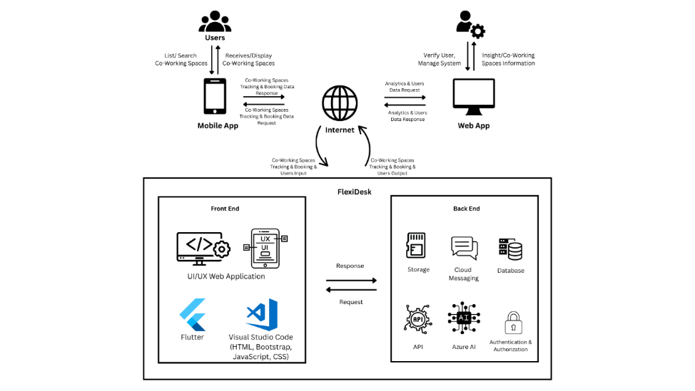

Figure 1. System Architecture Diagram

**Related Systems**

Murad N.S.I [8] investigates the characteristics that influence Filipino freelancers' intentions to utilize coworking spaces in Metro Manila, focusing on both physical and social components. Physical elements such as atmosphere, layout, facility aesthetics, and functioning demonstrated statistically significant associations with usage intention (p-values of 0.00), but cleanliness had a marginal impact (0.06). Social variables, such as member contact, involvement with community management, professional development events, and coworking culture, were also found to have a significant impact (p-values of 0.00). The findings show that, while both physical and social elements are important, the social aspects are more important, implying those Filipino freelancers value coworking spaces not only for the physical working environment, but also for the opportunities for collaboration, community support, and professional development. While the survey does not give statistics for the distribution or popularity of coworking spaces in the Philippines, it does provide useful localized information, underscoring the rising importance of coworking culture in Metro Manila's freelance economy.

Murad N.S. I’s study highlights that Filipino freelancer value both the physical and social aspects of coworking spaces, with social factors like community engagement and professional development being more significant. For FlexiDesk, this suggests the app should prioritize features that track both the physical environment (layout, aesthetics) and social opportunities (events, networking, community support) to better cater to freelancer needs in Metro Manila. Cleanliness could also be included as a rating feature, but the focus should be on fostering a collaborative, supportive workspace culture.

Additionally, Atienza, I.M.N [9] evaluated at how young Filipino people in advertising and marketing evaluate coworking space interiors and their suitability as WFH alternatives in hybrid setups. Interviews with ten Metro Manila-based participants (ages 20-35) using Kaplan's Attention Restoration Theory demonstrated a preference for contemporary designs including diverse workstations and natural features. Coworking facilities are more appealing to people working full-time or on-site than hybrid workers. The report proposes broadening future research to include more sectors and larger samples.

Atienza I.M. N’s study regarding how young Filipino advertising and marketing workers view coworking spaces gives useful information for FlexiDesk. The demand for contemporary architecture, various workstations, and natural elements is consistent with the physical aspects that freelancers and hybrid workers evaluate when selecting a coworking space. For FlexiDesk, this means the app may include filters or categories that showcase coworking spaces with modern, multifunctional designs and natural aspects. Furthermore, the contrast between full-time and hybrid worker preferences shows that FlexiDesk might make personalized suggestions based on the user's work configuration, meeting the demands of both full-time and hybrid professionals.

The Executive Centre (TEC) [10], Asia's premier provider of flexible workspaces, saw strong growth in the Philippines and Southeast Asia in 2023 due to rising demand for flexible office solutions. TEC increased its Southeast Asian footprint by establishing four additional centers, including Ayala Triangle Gardens Tower 2 in Manila, which will open in October 2023 with 358 workstations. As of September 2023, TEC's Manila centers had the highest occupancy rate in the area, with 98%, followed by Singapore, Ho Chi Minh City, and Jakarta centers at 95%, 91%, and 81%, respectively. Overall, the Philippine office market benefits from the strong performance of the information technology-business process management (IT-BPM) sector, with Metro Manila maintaining a popular destination for global industry players. As of 2023, the country office stock was 18.1 million square meters, with Metro Manila accounting for 82%. Of total, 81% (14.6 million square meters) was leased, resulting in a 19% vacancy rate, mostly in recently constructed buildings. Bonifacio Global City and Makati City have the lowest vacancy rates, at 9% and 13%, respectively.

This context can be directly supports the benefit and potential of FlexiDesk, a web tool for scheduling and tracking coworking spaces. FlexiDesk can serve a concentrated and dynamic market. As new coworking facilities open and occupancy stays strong, FlexiDesk provides a simplified platform that benefits both users and space providers by allowing for real-time booking, availability tracking, and data-driven analytics. FlexiDesk may be a great tool for coworking space owners to track usage trends and optimize operations, while it also gives users with a simple and effective method to access flexible workplaces in high-demand regions.

Willis Towers Watson [11] found when Luzon was under its strictest lockdown, 99% of office-based firms allowed employees to work from home and 44% facilitated social distancing through minimal office staff and staggered shifts. Around half the companies surveyed had adopted multiple types of work arrangements for their employees. While in many cases this shift has been essential, some members of the newly remote workforce have faced challenges such as inadequate work space and poor ICT infrastructure. This is especially important as the digital shift has put pressure on already lagging bandwidth. The Philippines’ average download speed for fixed broadband was 27.07 Mbps in October 2020, compared to 229.42 in Singapore, 183.58 in Thailand and 140.74 in China, according to Ookla’s Speed test Global Index. Indeed, the shift to remote work has highlighted the importance of improving connectivity. In April 2020 a World Economic Forum report on worldwide changes predicted that the pandemic would “catalyze sustained collaboration between the public and private sectors to increase internet access beyond the current crisis”. In the meantime, companies and employees are likely to search for alternatives. “In the Philippines people want to work near home, but not from home,” Lars Wittig, country manager of Regus and Spaces by IWG, told OBG. “This is because home internet connections are often poor, and it is not always easy to carve out a dedicated work space amid the neighborhood noise.”

According to a report by The Business Research Company [12], the global coworking space market size is expected to go up to $16.17 billion in 2022 from $13.60 billion in 2021 at a compound annual growth rate of 18.9%. The rise in global coworking space is primarily due to companies resuming operations and adapting to the new normal. By 2026, the coworking spaces market is expected to reach $30.36 billion, the report noted. From a local perspective, tech-savvy millennials drive the demand for shared office spaces. Coworking spaces provide an alternative work environment and serve as an arena where people can connect and network. According to JLL Philippines, 30% of commercial real estate could be coworking spaces by 2030, owing to the millennial generation, startups, and multinational corporations. It’s no surprise that larger organizations also take advantage of coworking spaces, especially if they are tapping a new market. There are many reasons why coworking space trends have become popular. Cost is one primary reason companies opt for coworking spaces instead of the traditional office spaces. With these shared office spaces, you get the functionality of a virtual office without the overhead expenses and investments. Coworking spaces also have more flexible leasing terms than traditional office spaces, so tenants don’t need to worry about lock-in contracts. Thanks to continuous advancements in technology and the internet, working outside the confines of a traditional office is made possible. Among many things that shaped our view in terms of the corporate workforce during the pandemic is that people can do their jobs out of the office without compromising their quality.

Abun, D. [13] investigated how job satisfaction is affected by the connections that exist at Divine Word Colleges in Ilocos Sur and Ilocos Norte, Philippines, between employers and workers as well as amongst employees themselves. College staff members were given questionnaires using a descriptive survey approach, and weighted mean and Pearson r correlation were used to evaluate the results. The results showed a strong link between job happiness and connections at work. Accordingly, the study suggests that management should keep a close eye on and improve relationships at work as well as other aspects that affect job satisfaction.

Positive interpersonal dynamics and job satisfaction were shown to be significantly correlated in research conducted among Divine Word Colleges workers in Ilocos Sur and Ilocos Norte on workplace relationships and job happiness. This has to do with FlexiDesk, which offers flexible, user-friendly workspace booking to improve the working environment. FlexiDesk focuses on the operational and physical components of the workplace, whereas the research centers on strengthening the bonds between employers and employees. Both seek to increase job happiness by attending to the logistical and social demands of employees. According to the survey, management should keep an eye on and improve connections at work, much as FlexiDesk gives employees the freedom to select the workplaces that best suit their needs.

Mátyus, E. [14] examines the function of coworking spaces in the business environment, emphasizing their value to society and productivity boost, particularly for remote workers. It looks at how the COVID-19 pandemic affected various areas and suggests using digitalization to modify their business strategies. The research integrates a literature analysis, methodology, and firsthand accounts from hub operators and members who kept their memberships through a case study of a coworking space in a small city in a developing nation. It uses the Business Model Canvas to illustrate a new business model and suggests a hybrid service strategy. The findings, which culminate with suggestions and questions for further study, represent the requirements of micro-entrepreneurs looking to develop their businesses creatively.

The study's conclusions, which highlight the necessity of digital change in coworking spaces, particularly in the wake of the Covid-19 outbreak, are in line with Flexidesk's concept. Both draw attention to the trend toward hybrid work arrangements and the need of easily accessible, adaptable services for microbusiness owners. By providing a digital platform that links users to coworking spaces and streamlines reservations and services to accommodate changing work demands, Flexidesk is a prime example of the type of business model innovation suggested in the research.

Reyes, R.R. [15] points out that the Philippines' continuous expansion of flexible workspaces is mostly due to the country's transition to remote and hybrid work patterns after the COVID-19 outbreak. In order to increase flexibility and efficiency over traditional office arrangements, businesses have been using digital technologies like virtual project management systems, cloud-based collaboration platforms, and video conferencing into their operations more and more. Because they promote company continuity, ease development, and lower investment risks, flexible office spaces have emerged as a crucial aspect of corporate strategy, especially for BPO organizations and traditional businesses, according to Sheila Lobien, CEO of Lobien Realty Group. In the Philippines, flexible workplaces already occupy more than 240,000 square meters of office space, demonstrating their expanding significance in the changing workplace culture.

Flexidesk's prominence in the expanding flexible workspace market is closely related to the article's observations. Platforms like Flexidesk, which digitally link users to coworking spaces that give the flexibility and efficiency contemporary businesses require, offer a handy alternative as firms increasingly adopt remote and hybrid work models. By simplifying workspace booking and access, Flexidesk facilitates this transition by making it simpler for conventional businesses, BPO organizations, and startups to discover flexible office solutions without long-term commitments—exactly the type of demand the article highlights.

According to Salesrain [16], the Philippines' coworking space market trends for 2023 show how the country is moving away from shared workplaces and toward vibrant hubs that encourage flexibility and teamwork. Demand from independent contractors, start-ups, and established companies looking for flexible leases and networking possibilities is fueling this expansion, particularly in Metro Manila. Additionally, coworking spaces are becoming more specialized to serve specialty industries like as creative professionals and IT firms. Coworking and regular office spaces are increasingly being combined in hybrid models, and the coworking experience is being improved by the use of technology like smart meeting rooms and high-speed internet. There are many of chances for innovation and growth in this industry.

Flexidesk offers tech-enabled, flexible coworking spaces to satisfy the need for flexible workspaces, particularly for independent contractors, new ventures, and well-established companies. Flexidesk's platform makes it easier to access both conventional office spaces and contemporary coworking settings, serving a variety of businesses as the industry embraces hybrid models and specialization. Flexidesk is positioned to benefit from these developments by incorporating technology for smooth booking and communication, providing a dynamic and adaptable solution for the changing workforce.

Cameron, R. [17] employs the notion of self-determination to examine the connection between individual performance and coworking space user happiness. Data from coworking space customers was gathered using a survey approach and a quantitative study design. Individual performance is directly impacted by addressing the demands of coworking users, according to the studies. In order to improve user happiness and performance, the study emphasizes how crucial it is to take into account user demands including relatedness, autonomy, and competence while designing and running coworking spaces. The study's limitations include cross-sectional data collection, non-probability sampling, and sample size, which raise the possibility that a longitudinal method might improve the results. In addition to applying self-determination theory to this context—an understudied area—the study advances our knowledge of the dynamics of coworking spaces.

One notable system is Spacematch, developed by Sood, Janssen, and Miller [17], which aligns user preferences with suitable activity-based workspaces. Through dynamic grouping of users with similar environmental preferences, Spacematch increases user satisfaction and workplace efficiency.

This kind of intelligent matching mechanism is relevant to FlexiDesk’s goal of smart workspace tracking based on user needs and preferences. It is in alignment with FlexiDesk's goal as a web tool for reserving and tracking coworking spaces. FlexiDesk may apply similar tactics by including user preferences, such as lighting, noise levels, and room temperature, into its booking system to deliver more tailored workplace suggestions. Furthermore, including real-time data—whether through IoT integrations or user feedback— can help FlexiDesk transform from a simple booking platform to a smart system that improves user experience and operational efficiency. This association lends credence to the premise that FlexiDesk has the potential to go beyond availability tracking.

Balmes, I.L., et al [19] created ParADA, a mobile-based Parking Application System that allows users to identify available parking spots near their present location by utilizing private properties leased by landowners in private institutions such as subdivisions and condominiums.

Both are similar in their approach to space efficiency via digital platforms. FlexiDesk can follow a similar strategy by cooperating with property owners, small firms, or organizations who are prepared to lease underutilized office or working spaces. FlexiDesk can assist users identify the nearest open coworking spaces by employing real-time data and geolocation capabilities, just like ParADA does for drivers. This method not only improves accessibility and convenience for users, but it also creates new revenue sources for space owners, encouraging more collaborative and efficient use of urban infrastructure.

Golo, M.A.T. and Encarnacion, R.E. [20] addresses inefficiencies in the car rental market on Siargao Island, Philippines, where manual procedures result in inconsistent services and a poor customer experience despite thriving tourism. To solve these challenges, the researchers suggest developing an online car rental   
management system that automates reservations, optimizes fleet management, and gives real-time updates. Using a mixed-methods approach that includes surveys, interviews, and ethnographic studies, the study finds a high need for a digital solution. The suggested solution intends to increase operational efficiency, service dependability, and customer happiness while also enabling local rental firms to compete in the digital age.

The study by Golo and Encarnacion on inefficiencies in Siargao's automobile rental sector is consistent with FlexiDesk's objective of enhancing coworking space management. Just as the proposed online vehicle rental system intends to simplify reservations and improve customer experience, FlexiDesk offers a digital solution for coworking spaces that streamlines bookings, gives real-time updates, and optimizes space management. Both solutions meet the demand for operational efficiency and enable local firms remain competitive in a digital economy, therefore contributing to long-term growth.

German, J. D., et al. [21] enhanced the process of facility reservation at a higher education university in the Philippines. Various bodies in charge of managing various sorts of facilities and rooms were spread over the campus, necessitating extensive travel. There were also various concerns with the availability of authorized people responsible for allowing access to the facilities. An online resource and management system was created using information system design to simplify room and facility management, handle real- time information sharing, reduce the effort and time necessary to make a reservation, and allow users to easily access and exchange information at hand.

German et al. designed a facility reservation system to expedite room and facility management in a university context, which closely matches with FlexiDesk's aims. Both solutions seek to increase the efficiency of space booking by automating procedures and delivering real-time data. FlexiDesk streamlines coworking space reservations, comparable to how German et al.'s method tackles campus facility access and administration difficulties. By centralizing the reservation process and boosting accessibility, both technologies save consumers time and effort while increasing operational efficiency. FlexiDesk, like the university system, provides quick access, real-time updates, and streamlined space management, resulting in a smoother, more structured experience for both users and space owners.

German, J. D., et al. [22] launched the Appoint Deportes online system, a web-based tool that allows users to identify sports facilities online and deal with the establishment's proprietors while arranging leisure or training activities. It is a unique application that allows users to simply reserve or schedule an appointment at a certain sports facility and view its availability in real-time. A systems flowchart and a data flow diagram were built to show how the proposed system's actions and information flow. Interviews with various persons who have expertise designing an online application were also done to establish the criteria for creating the program's user interface. Using these tools and methodologies, the research was able to solve the flaws that existed in the previous reservation system, resulting in the development of a more dependable and accurate online reservation system that can assist people, organizations, and sports facility owners. The online reservation system allows for rapid and paperless transactions, which are both economically and ecologically effective. It reduces costs by reducing the need for manual entry and processing, resulting in reduced pricing for customers and more profits for enterprises.

German et al.'s Appoint Deportes online solution is clearly related to FlexiDesk in terms of simplifying space reservation and increasing operational efficiency. Both systems promise to provide real-time availability tracking and paperless transactions, hence improving user ease and reducing administrative cost. Just as "Appoint Deportes" allows users to quickly reserve sports facilities online and engage with owners, FlexiDesk allows users to book coworking spaces and track availability in real time, which benefits both people and space owners. Furthermore, just as the Appoint Deportes system focuses on creating a user-friendly interface, FlexiDesk would stress simplicity of use to provide a pleasant booking experience. Both technologies minimize the need for human processing, cut operating expenses, and bring economic and environmental advantages, resulting in increased user satisfaction and corporate profitability. This method frames FlexiDesk as a useful tool for managing coworking spaces, similar to how "Appoint Deportes" alters sporting facility bookings.

Leona, R. F., et al [23] assessed AppStay's technical features demonstrated a high degree of acceptance, as evidenced by good assessments from IT specialists.   
Furthermore, the study discovered that the system had very good usability. These findings suggest that AppStay is suitable for usage in the study's local environment. However, the researchers made some recommendations to improve the system's usability and performance. Finally, the creation and evaluation of AppStay produced encouraging results, demonstrating its potential as an effective web-based reservation system.

Leona et al.'s findings on AppStay show the significance of usability and performance in web-based reservation systems, which are closely related to FlexiDesk's aims. FlexiDesk, like AppStay, intends to establish a user-friendly platform for scheduling coworking spaces, and the strong feedback on AppStay's usability indicates that a similar approach for FlexiDesk would be well-received. The study's proposal to constantly improve the system's usability and performance aligns with FlexiDesk’s aim of improving user experience and adapting to the changing demands of its users.

Gosela, R.R.U. and Encarnacion, R.E. [24] developed The LakByahe App, a unified digital platform aimed at transforming tourism in Nasipit, Agusan del Norte, Philippines. It improves productivity, accessibility, and sustainability by offering location-based services, real-time tracking, and simplified reservations. The app connects travelers with local companies, so promoting economic growth. The study, which follows the software development life cycle and is influenced by a mixed-method research methodology, proposes additional features such as augmented reality, tour packages, community forums, and offline map access. Continuous collaboration, user training, frequent updates, and efficient marketing are advised to optimize the app's usefulness in promoting tourism and regional development.

The LakByahe App, created by Gosela and Encarnacion, bears many similarities with FlexiDesk, notably in how both systems seek to increase efficiency, accessibility, and user experience through digital solutions. Just as LakByahe improves tourism in Nasipit by providing real-time tracking, simpler bookings, and location-based services, FlexiDesk aims to simplify coworking space reservations by providing users with real-time availability and location-specific alternatives. Both applications aim to link users with local services—in FlexiDesk's case, coworking spaces—while also boosting economic growth by making transactions more accessible and simpler. As with LakByahe, FlexiDesk benefits from continuing upgrades and feedback loops to guarantee the platform satisfies user demands and remains competitive in the continuously developing coworking space industry. In essence, both platforms seek to allow easier, more efficient interactions between users and local service providers, therefore promoting regional growth and user happiness.

Reyna, A.C.C. [25] explains the creation and deployment of a web-based PUV reservation application for the Integrated Land Transport Terminal in Surigao City. The application was created using a user-centric approach, guaranteeing flexibility and ongoing development, by utilizing object-oriented analysis and design and the prototype software development paradigm. The application, which was developed with the Laravel framework, provides object-oriented programming support, scalability, and efficiency. By offering a user-friendly interface for seat bookings, real-time seat availability display, and set departure times and destination information, the app solves the problems commuters have with terminal-based PUV services and, in the end, improves the commuter experience.

Key parallels exist between Flexidesk's platform and the creation of the Web-Based PUV Booking App for Surigao City, especially with regard to its user-centric design, digital service delivery, and emphasis on real-time availability. Flexidesk makes workspace bookings easier by providing real-time availability and smooth booking features, much like the PUV app makes commuting easier with effective seat booking and current information. Using contemporary frameworks—web-based tools for Flexidesk and Laravel for the PUV app—both platforms place a high priority on usability, scalability, and efficiency. In the end, both methods improve ease and consumer pleasure by addressing conventional service gaps through technology.

Hutke, A., et. al, [26] created one kind of software that lets consumers schedule appointments with service providers online is BookEazy, an appointment booking tool. Applications for scheduling appointments have become essential tools in contemporary service sectors, enabling smooth scheduling between customers and service providers. Applications for scheduling appointments provide several advantages for both clients and service providers. They can also assist users in tracking their appointments and determining the ideal time and date. Applications for scheduling appointments can increase productivity and client satisfaction for service providers. These apps can help lower the frequency of cancellations and no-shows by making it simple for users to schedule appointments. Additionally, they can assist service providers in better time management and appointment tracking.

The goals and capabilities of Flexidesk closely align with the features and advantages of the BookEazy appointment scheduling tool. Flexidesk makes coworking space booking easier by enabling users to quickly reserve work areas, conference rooms, or private offices, much like BookEazy makes scheduling between customers and service providers easier. By offering real-time booking alternatives, decreasing no-shows, and enhancing service coordination, both platforms increase customer pleasure, productivity, and time management. Flexidesk is in line with the larger trend of digital solutions revolutionizing service accessibility and operational efficiency, as seen by its common emphasis on effective scheduling and enhanced user experience.

Abdul, A.S., et. al [26] created a vehicle monitoring program with the goal of increasing the precision of taxi, rail, and bus arrival times. The application tracks the whereabouts of vehicles using GPS on Android handsets and saves the information in a Firebase Real-time Database for rapid synchronizing. In order to determine journey times depending on routes and traffic conditions, it also incorporates the Google Distance Matrix API. The prototype demonstrated increased accuracy in predicting vehicle arrival times following several testing stages and user input.

Flexidesk's objective of improving user comfort through technology is well aligned with the vehicle monitoring program's emphasis on real-time tracking and precise arrival forecasts. Flexidesk guarantees effective coworking space management by offering real-time availability and booking tools, just like the program enhances transportation dependability using GPS and real-time databases. Flexidesk might incorporate comparable capabilities to assist customers in better planning workspace utilization, particularly for time-sensitive reservations, as demonstrated by the use of the Google Distance Matrix API to optimize timing. In order to improve the overall user experience, both systems place a strong emphasis on responsiveness, real-time updates, and user feedback-driven improvement**.**

**CHAPTER 3**

# DESIGN AND METHODOLOGY

This chapter will present the strategy and procedures to be undertaken in the development of the research project. The following are expected the included in this chapter:

**Data Gathering**

The researchers utilized both quantitative and qualitative methods in gathering essential data necessary for the development of FlexiDesk: A Smart Web Application for Tracking and Booking Co-Workspace Environment. These methods were used to gain insights into the behaviors, preferences, and challenges experienced by individuals and organizations when booking and managing co-working spaces. The gathered data helped identify user expectations, evaluate existing booking processes, and define system features aligned with modern workspace trends.

For the quantitative method, the researchers distributed structured survey questionnaires with closed-ended questions to a targeted group of respondents, including students, freelancers, small business owners, and co-working space operators within urban centers. The survey focused on key variables such as workspace booking frequency, preferred amenities, payment method preferences, and interest in smart features like AI recommendations, and real-time availability tracking. The data collected provided a clear understanding of what functionalities should be prioritized in the system, such as secure payments, dynamic pricing, and user-friendly booking features.

In addition to surveys, the researchers conducted interviews with co-working space managers and frequent users to gather qualitative insights. These semi-structured interviews explored common issues such as overbooking, communication gaps between clients and space providers, and lack of smart management tools. The feedback gathered supported the integration of real-time calendar syncing, automated notifications, and an in-app chat system to enhance user interaction and booking transparency.

Given that the system aims to cater to a wide range of users, including students and professionals, the interviews and surveys were conducted with careful consideration of ethical research practices, including informed consent and data confidentiality. The combination of both data gathering methods ensured that the development of FlexiDesk is grounded in real user needs, supports digital transformation in workspace management, and promotes a more efficient, accessible, and intelligent co-working environment.

**Project Concept**

In today’s fast-evolving work culture, co-working spaces have become an essential part of the modern workforce, especially for freelancers, remote employees, startups, and small businesses. However, the management and utilization of these spaces often face inefficiencies, including double bookings, lack of real-time availability, and poor resource tracking. To address these issues, the proposed project FlexiDesk aims to develop a smart web-based application that enables users to track, reserve, and manage co-working spaces efficiently.

FlexiDesk is envisioned as a centralized platform that provides real-time visibility of available workspaces, meeting rooms, and other shared facilities. Through the system, users can browse workspace availability, make bookings, modify or cancel reservations, and receive instant notifications or confirmations. Meanwhile, administrators and facility managers will have access to a backend dashboard to monitor space utilization, manage bookings, and generate analytics reports that can guide operational decisions.

The system will integrate features such as real-time occupancy tracking, automated scheduling, user authentication, payment options, and usage analytics. It will be designed with an intuitive user interface that is both desktop and mobile-friendly, ensuring accessibility and ease of use for all users.

The primary goal of FlexiDesk is to enhance user experience and operational efficiency within co-working environments. By automating and optimizing the booking and tracking processes, the system aims to reduce human error, improve space utilization, and support a more flexible and data-driven.

**Development Method**

To ensure the successful development of FlexiDesk, a smart web application for tracking and booking co-working spaces, the Agile software development methodology was adopted. Agile was chosen for its iterative and flexible approach, which is well-suited for projects that require continuous user feedback and regular updates. Given the dynamic nature of co-working environments and the diverse needs of users—from freelancers and startup teams to space administrators—the Agile model allowed the development team to respond to changing requirements and incorporate stakeholder input at every stage of the project.

The development process was divided into a series of time-boxed iterations called sprints, each lasting approximately two to three weeks. Each sprint focused on building specific modules or features of the system, such as user authentication, real-time workspace tracking, booking management, and administrative dashboards. At the end of each sprint, a working version of the application was reviewed and evaluated through stakeholder feedback sessions, which enabled the team to refine features, fix bugs, and align the system more closely with user expectations.

The process began with an in-depth requirement analysis phase, where data collected through interviews, surveys, and observations was analyzed to define user stories and system functionalities. This was followed by system design, where wireframes, user interface prototypes, and system architecture were developed to guide the coding phase. During development, modern technologies such as HTML5, CSS, JavaScript (with React or Vue.js), and a backend framework like Node.js or Laravel were used to build a responsive and scalable application. Testing was conducted continuously throughout each sprint, using a mix of unit testing, integration testing, and user acceptance testing to ensure quality and reliability.

Upon completion of development, the application was deployed to a live environment where real-world performance was monitored. Any identified issues were resolved promptly, and feedback from early users was used to guide ongoing maintenance and future updates. By following Agile methodology, the FlexiDesk development team ensured that the application remained user-focused, adaptable, and capable of meeting the real-time demands of modern co-working space management.

**Figure 2. Agile Method**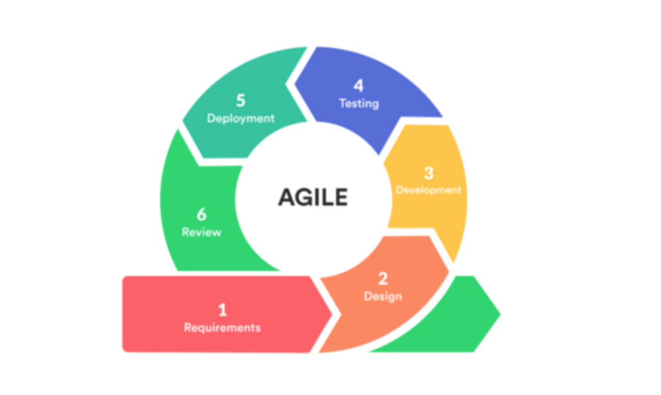

## **Development Approach**

The development of FlexiDesk followed a top-down approach, which is ideal for systems requiring clear structure, modularity, and user-centered design. This strategy began with a high-level understanding of the system’s overall functionality, focusing first on the core objectives—namely, providing an efficient, real-time platform for tracking and booking co-working spaces. From this top-level vision, the system was gradually broken down into smaller, more manageable subsystems and components, ensuring that each module aligned with the main goals of usability, accessibility, and operational efficiency.

At the initial stage, the main functionalities of FlexiDesk such as user registration, workspace availability tracking, booking management, and administrative controls were clearly defined and documented. These core functions were then decomposed into smaller submodules, including user interface components, backend logic, database management, and system integration with calendar and notification tools. This top-down breakdown allowed the development team to focus on individual components while maintaining alignment with the system’s overall architecture and user requirements.

Each layer of the system was developed with a clear understanding of how it contributes to the entire application. The user interface was designed first as part of the top layer, using wireframes and prototypes to visualize how users would interact with the system. Meanwhile, backend services and database structures were developed to support these interactions, ensuring consistency and reliability in features such as real-time booking updates and user activity tracking.

By using the top-down approach, FlexiDesk’s development process remained focused and organized, enabling smooth integration of each component into a cohesive, functional system. This method also supported effective testing and iteration, as higher-level modules could be validated early and refined continuously, with lower-level components added as they were completed. The result is a well-structured, scalable application that meets both technical standards and user 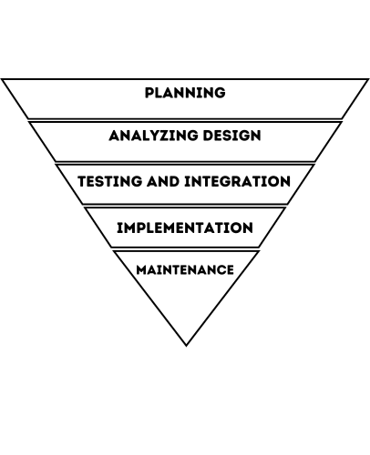expectations in the co-working environment.

**Figure 3. Top-Down Approach**

**System Analysis and Design**

The system analysis and design phase for FlexiDesk played a critical role in ensuring the application’s functionality, usability, and operational efficiency. This phase involved understanding user needs, defining system requirements, and creating a structured design that would guide the development process. A combination of techniques—including requirement analysis, data modeling, process modeling, and interface design—was used to thoroughly analyze the system and build an effective architectural blueprint.

During the requirement analysis phase, data was gathered from users and co-working space administrators through interviews, surveys, and observations. This helped the team identify key system functions such as user registration, workspace browsing, real-time availability tracking, booking and cancellation, notifications, and administrative controls. These requirements were categorized into functional requirements (what the system should do) and non-functional requirements (such as performance, scalability, and security).

Following this, the system was modeled using various tools and techniques. Use case diagrams were developed to visualize the interactions between users and the system, highlighting the different functionalities available to regular users and administrators. These included use cases such as “Book Workspace,” “Check Availability,” “Manage Reservations,” and “Generate Reports.” The use case analysis ensured that every user action was accounted for in the design and that the system would be intuitive to navigate.

For data modeling, Entity-Relationship Diagrams (ERDs) were used to define the data structure and the relationships between entities such as Users, Workspaces, Bookings, Payments, and Notifications. This ensured that the database design would support efficient data storage, retrieval, and integrity. The ERD helped in creating a normalized database schema that minimized redundancy and enhanced query performance.

Process modeling was also performed using Data Flow Diagrams (DFDs) to map out how data moves through the system—from the moment a user logs in, to checking workspace availability, making a booking, and receiving confirmation. This clarified system operations and supported the development of logical process flows that could be translated into code efficiently.

The system design phase then translated these models into a modular architecture. A layered design was used, separating the system into presentation (frontend), logic (backend), and data (database) layers. The frontend was designed with user experience in mind, using wireframes and mockups to create a clean, responsive interface accessible via web browsers and mobile devices. The backend was built to handle processing, business rules, and system logic, ensuring smooth communication between the interface and the database. API’s were also planned for real-time data updates, particularly for displaying workspace availability and booking statuses.

Special attention was given to usability, ensuring that the interface was easy to navigate, visually appealing, and required minimal training. Features like search filters, calendar views, and automated booking suggestions were designed to enhance user satisfaction. Meanwhile, efficiency was addressed through database optimization, caching mechanisms, and lightweight design elements to support fast loading and minimal downtime. efficiency.

**Context Flow Diagram**

Figure 4 below illustrates the high-level system architecture of FlexiDesk: A Smart Web Application for Tracking and Booking Co-Workspace Environment, showcasing how different components and users interact within the system. At the core is the FlexiDesk platform, which serves as the central hub for all interactions. Clients—who may be students, professionals, or organizations—access the system to search for, book, and manage co-working spaces. Their interaction is supported by a Booking Engine, which handles real-time availability checks, prevents double bookings, and facilitates scheduling. Integrated with this engine is a Search, Calendar, Payment, and AI module that enables smart recommendations, calendar syncing, secure digital payments, and user-friendly search functionalities.

Once a booking is made, Smart Access Control ensures that clients can securely enter their reserved spaces using QR codes or smart authentication methods. On the other side, Workspace Owners use the system to list and manage their available workspaces, including pricing and availability. These listings are subject to review and monitoring by the Admin Module, which is responsible for verifying workspace information, handling conflict reports, managing analytics, and maintaining system security and policy compliance. The admin also serves as a bridge between the platform’s operational backend and the users, ensuring that the system runs smoothly and aligns with the objectives of service quality, reliability, and user safety. Overall, the diagram reflects an interconnected ecosystem designed to automate, simplify, and secure the co-working space booking process for all 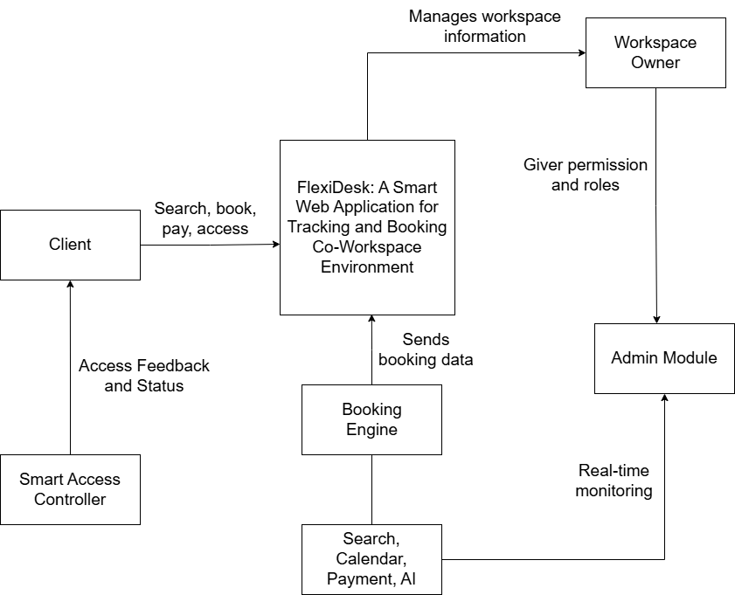stakeholders.

**Figure 4. Context Flow Diagram**

## **Data Flow Diagram**

Figure 5 below depicts the User Account Management process in a data flow diagram. It outlines how a User manages their personal account information within the system. The user has four core interactions: registering an account, viewing account details, updating account details, and deleting an account. In the registration process (Process 1.0), a user submits personal information to create a new account, which is then stored in the User Account data store.

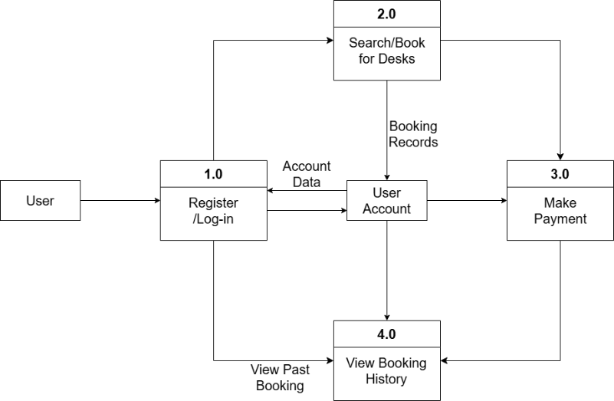Through the view account process (Process 2.0), users can request to view their profile details, and the system retrieves and displays their stored account information. When updating an account (Process 3.0), the user modifies their profile details, and the system updates this information in the user account data store. If the user decides to delete their account (Process 4.0), the system permanently removes their account data from storage. This DFD clearly illustrates how users can independently manage their account lifecycle through these four primary functions.

**Figure 5. Data Flow Diagram for FlexiDesk User**

The diagram in the next page, Figure 6, represents the Admin Reservation Management process in a data flow diagram (DFD). It shows how an Admin interacts with the system to manage reservation records effectively. The admin can perform four main operations: viewing, creating, updating, and deleting reservation records. When the admin chooses to view reservation records (Process 1.0), a request is sent to retrieve and display all stored reservation details from the Reservation Records data store. In the creation process (Process 2.0), the admin inputs new reservation details, and the system saves these into the reservation records. For updating records (Process 3.0), the admin selects an existing reservation, modifies its details, and the system updates the information in the data store accordingly. Finally, the admin can also delete a reservation (Process 4.0), which removes the corresponding entry from the reservation records. This DFD demonstrates a typical CRUD (Create, Read, Update, Delete) cycle handled by an 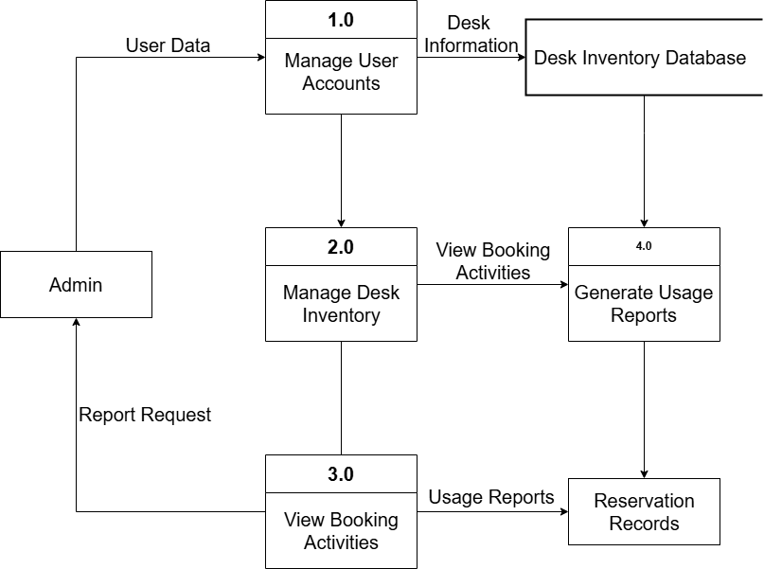administrator to maintain the reservation database.

**Figure 6. Data Flow Diagram for FlexiDesk Admin**

## **Functional Requirements**

This section presents the functional requirements of FlexiDesk: A Smart Web Application for Tracking and Booking Co-Workspace Environment define the core features and services the system must provide to meet the needs of its users. These include key functionalities such as user registration and login, workspace searching and booking, secure payment processing, real-time availability tracking, and communication between users and workspace providers. The goal of these requirements is to ensure that the system operates effectively, provides a seamless user experience, and supports the efficient management of co-working spaces.

**Table 1. Functional Requirements**

|  |  |
| --- | --- |
| **Characteristics** | **Description** |
| **User Authentication and Role-Based Access** | Client (Student/Worker/Organization): Secure login, role-based access control to ensure that clients can only access their respective features (e.g., booking, searching, payments). Owner: Owners can manage workspaces, view booking details, and access payment information. Admin: Full access to system-wide settings, user management, and analytics. |
| **Search and booking** | Ability for clients to search for co-working spaces based on filters like location, availability, pricing, and amenities. View workspace details (images, descriptions, reviews). Real-time synchronization of bookings with a calendar to prevent double bookings.  Store favorite venues, set preferences, and receive updates on deals. |
| **Automated Scheduling and Smart Access** | Instant booking of spaces with automated calendar updates. Provide QR code or smart keycard access for seamless entry. |
| **Payment System** | Secure payment gateway integration (supporting credit/debit cards, mobile wallets). Digital wallet for easy transaction management. |
| **Communication and Workspace Management** | In-app chat functionality for communication between clients and workspace providers. Real-time notifications about bookings, updates, and promotions. User review and rating system to evaluate spaces and services. |
| **Cancellations and Refunds** | Ability for clients to cancel bookings as per the platform’s cancellation policy. Refund requests with necessary documentation submission and status tracking. |
| **AI-Driven Pricing, Promotions, and Recommendations** | Dynamic pricing based on demand, time, and user preferences. AI-powered workspace recommendations based on past bookings and preferences. |
| **Data Analytics and Performance Insights** | Admins can monitor occupancy rates, peak booking hours, and income reports. Analytics on high-performing workspaces, cancellation rates, and payment patterns. |
| **Fraud Detection and Security** | Use Azure AI to detect fraudulent bookings, reviews, and suspicious activities. Maintain secure user data using encryption techniques. |
| **Analytics and Predictive Features** | Descriptive, predictive, and prescriptive analysis for trend forecasting, customer engagement, and pricing optimization. |
| **Testing and Evaluation** | System must be evaluated using test cases and ISO/IEC 25010 2011 software evaluation standards for functionality, performance, reliability, and usability. |

**Non-Functional Requirements**

This section outlines the non-functional requirements of FlexidDesk: A Smart Web Application for Tracking and Booking Co-Workspace Environment define the system's overall performance characteristics, ensuring that it operates efficiently, securely, and reliably under various conditions. These requirements focus on how the system performs rather than what it does, addressing critical areas such as scalability, usability, security, availability, maintainability, and system responsiveness.

To support a diverse user base including clients, workspace owners, and administrators FlexiDesk must provide a seamless and intuitive experience across multiple devices and platforms. The application must handle high traffic volumes during peak booking periods while maintaining fast response times and ensuring data integrity. Robust security measures, including data encryption, access control, and fraud detection, are necessary to protect user information and maintain trust. Additionally, the system must be designed for long-term maintainability and scalability to accommodate future updates, user growth, and integration with third-party services.

**Table 2. Non-Functional Requirements**

|  |  |
| --- | --- |
| **Criteria** | **Description** |
| **Performance Efficiency** | The system must support high volumes of simultaneous users without performance degradation. Fast response times for real-time booking updates and availability checks. The platform should handle peak booking periods and high-demand times efficiently. |
| **Reliability** | The system should be highly available, with minimal downtime or outages. Ensure data consistency, especially when multiple users are making bookings or changes at the same time. |
| **Scalability** | The system must be able to handle an increasing number of users and workspaces without requiring major architectural changes. Support for new integrations and expanded functionalities over time. |
| **Usability** | The platform should have an intuitive, easy-to-navigate interface for both clients and workspace providers. Provide user-friendly guides or tutorials for new users. Ensure the user experience is consistent across different devices (desktop, mobile). |
| **Security** | Use encryption (SSL/TLS) for data transmission and secure storage of sensitive user data (payment details, user credentials). Implement robust authentication mechanisms, including two-factor authentication (2FA) for enhanced security. |
| **Availability** | The system should have an uptime of 99.9% or higher, with contingency plans in place for disaster recovery and fault tolerance. |
| **Maintainability** | The system should be modular and easily maintainable, with clear separation between frontend, backend, and database layers. Use of version control and automated testing to ensure smooth updates and bug fixes. |
| **Interoperability** | FlexiDesk must be compatible with various third-party services for payment processing, calendar integration. |

## **User Design Interface**

Figure 7 below appears to be the homepage of the "FLEXIDESK" platform. At the top, the logo is visible, along with "FlexiDesk Space" and user profile/menu icons (1, 2). A prominent search bar (3) with fields for "Where," "Check in," "Check out," and "Who" is displayed, suggesting users can search for spaces based on location, dates, and number of people. Below the search bar, a category section (4) shows various "Space" options represented by icons and labels. Listings of available spaces are displayed as cards (5) with placeholder images, titles, brief location details, distance, and a price per night. A heart icon for saving is on each card. A "Map" button (6) is located at the bottom, likely to switch the view to a map interface. Navigation arrows (7, 8) indicate the possibility of scrolling through more categories or listings.

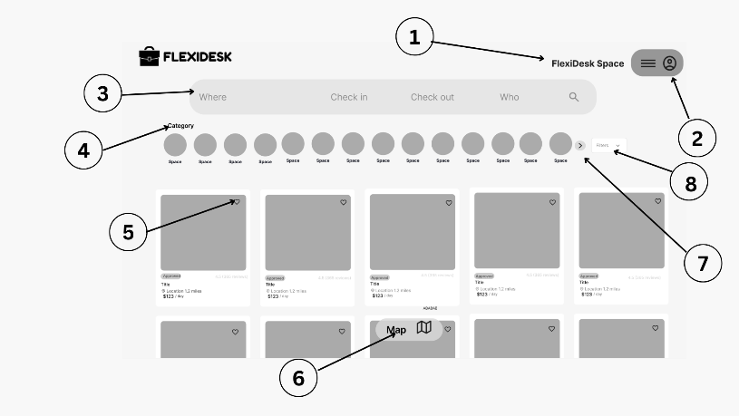

**Figure 7. Home Interface**

1. **FlexiDesk Space link**
2. **Account login/Sign Up settings**
3. **Where, when and Who search bar**
4. **Category**
5. **Heart Button**
6. **Map Button**
7. **Forward Button**
8. **Filter Button**

Figure 8 in the next page shows a map interface displaying the geographical distribution of available workspaces. Markers on the map likely indicate the location and price of each workspace. At the bottom left, a "List" button (arrow 1) allows users to toggle back to a text-based list view. On the right side, zoom controls (arrows 2 and 4) and a button to reset the map view (arrow 3) are provided for navigation.

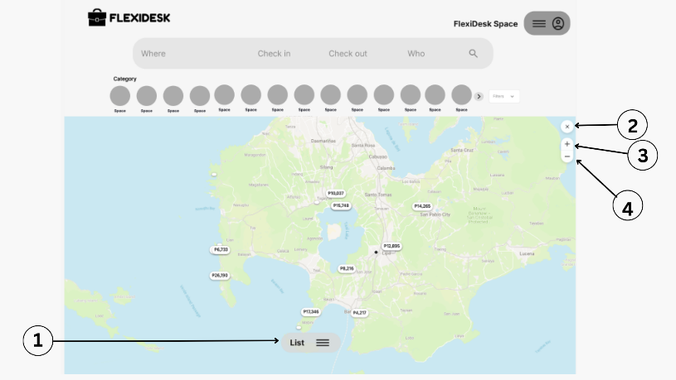

**Figure 8. Map Interface**

1. **Close Button**
2. **Zoom in Button**
3. **Zoom out Button**
4. **List Button**

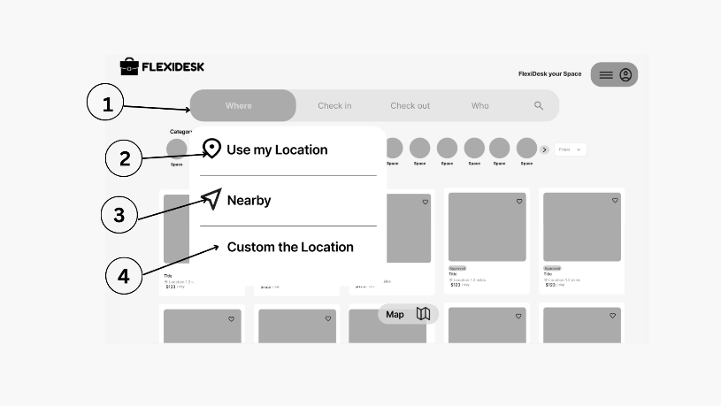Figure 9 below focuses on the "Where" search field (arrow 1) and the options presented when a user interacts with it. A dropdown menu appears with choices to "Use my Location" (arrow 2), search for workspaces "Nearby" (arrow 3), or "Custom the Location" (arrow 4). These options provide flexibility in specifying the desired area for workspace search.

**Figure 9. Search Where Interface**

1. **Where Toggle**
2. **Location**
3. **Nearby**
4. **Custom**

Figure 10 below shows the calendar interface that appears when a user interacts with the "Check out" field (arrow 1). The calendar displays the months of May and June 2025 (arrow 2), with potential check-in dates highlighted. Users can select their desired check-out date. Options for selecting exact dates or pre-defined durations (like ±1 day, ±2 days, etc.) are available at the bottom (arrow 4), along with a "Clear dates" option.

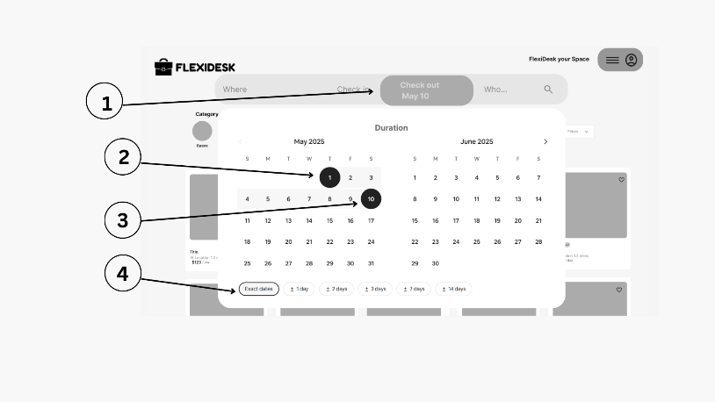

**Figure 10. Search When Interface**

1. **Check in and check out toggle 2. Start**
2. **End 3. Checking out duration**

Figure 11 in the next page highlights the "Who" filter (arrow 1) on the search results page. Upon interaction, a dropdown menu (arrow 2) appears, allowing users to filter workspaces based on the types of people who might be using the space. Categories such as "Coleagues/ Co-peers," "Students," "Co-owners," "Researchers," "Freelancers," and whether "Pets" are allowed are available for selection (arrow 2). A "Map" button (arrow 3) is also present for viewing filtered 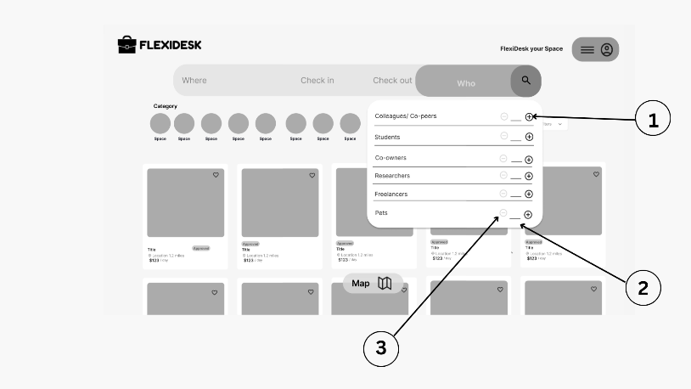results on a map.

**Figure 11. Add Who Interface**

1. **Increase Button 2. Number of Guests Display**
2. **Decrease Button**

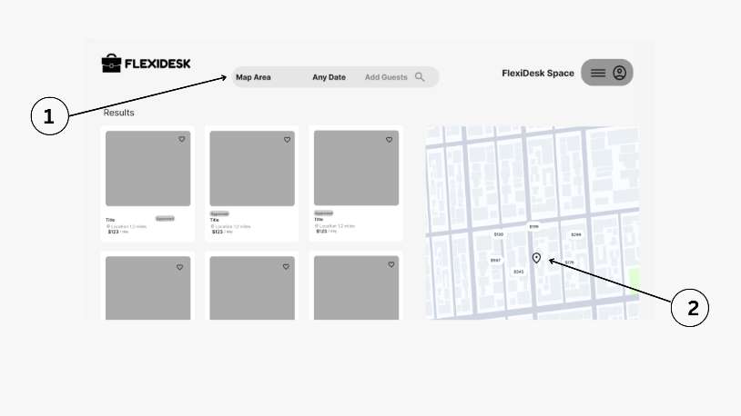Figure 12 below shows a split-screen view of workspace search results. On the left (arrow 1), a list of results is displayed, while on the right (arrow 2), a map shows the geographical locations of these workspaces. This layout allows users to see both the details of the listings and their spatial relationships.

**Figure 12. Map Area**

1. **Search bar with map area, anydate, add guests**
2. **Location Symbol**

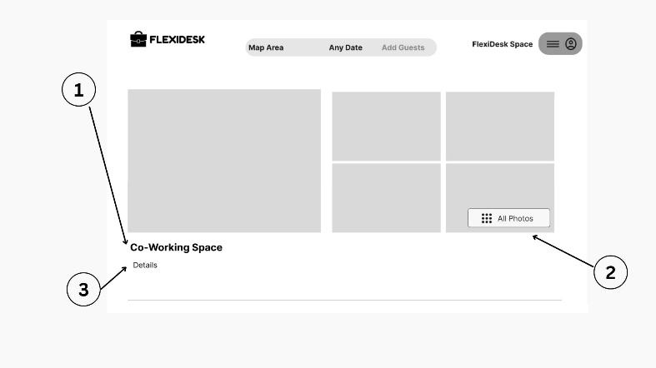 Figure 13 below displays a preview of the photo gallery for a specific workspace labeled "Co-Working Space" (arrow 1). A main image is shown on the left, with thumbnails of other photos displayed to the right. An "All Photos" button (arrow 2) suggests that users can view the complete set of images for this workspace.

**Figure 13. Co-Working Space Details Interface**

1. **Co-Working Space Label**
2. **All photos button**
3. **Details**

Figure 14 below outlines the layout of a detailed workspace information page. It indicates sections for the "Description" (arrow 4) of the workspace, the "Amenities" offered (arrow 5), and "Review" information (arrow 6), including an overall rating and ratings for specific aspects like cleanliness, accuracy, and location.

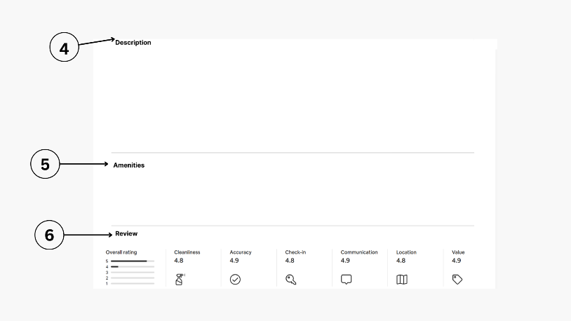

**Figure 14. Co-Working Space Details Interface**

1. **Description**
2. **Amenities**
3. **Review**

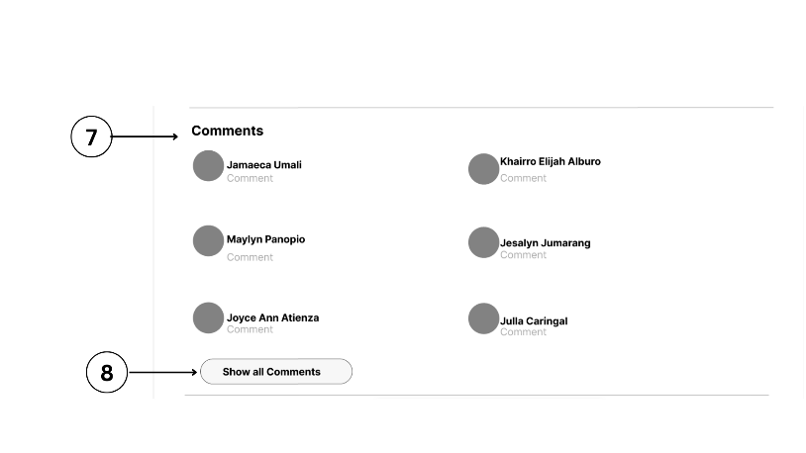Figure 15 below shows the "Comments" section (arrow 7) on a workspace details page. It displays previews of comments left by previous users, including their names. A "Show all Comments" button (arrow 8) indicates that more detailed reviews are available to read.

**Figure 15. Co-Working Space Details Interface**

1. **Comments Section**
2. **Show Comment Button**

Figure 16 below presents a booking summary for a 5-night stay. It shows the check-in and check-out dates, the number of guests, and different rate options (non-refundable and refundable) with their respective prices and cancellation policies (arrow 14). A "Reserve" button (arrow 13) allows the user to proceed with the booking. The total price is displayed (arrow 16), and it's noted that the user won't be charged immediately (arrow 12). A calendar (arrow 9) with selected dates (arrow 10) is also visible, along with host information (arrow 11) and the number of guests (arrow 15).

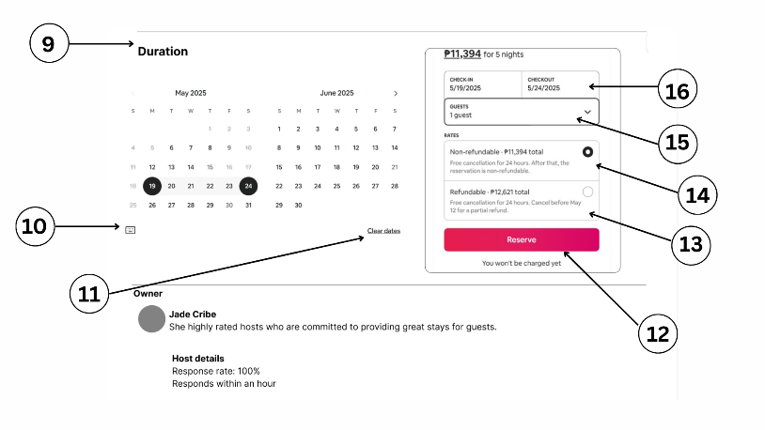

**Figure 16. Co-Working Space Details Interface**

1. **Duration**
2. **Keyboard Symbol**
3. **Duration Dropdown**
4. **Add guest’s dropdown**
5. **Refundable Radio Button**
6. **Reserve**
7. **Number of Guest**
8. **Calendar**

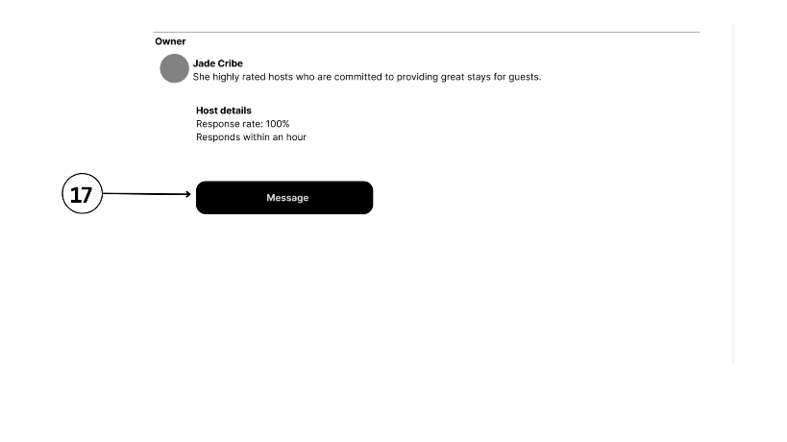 Figure 17 below shows a section of a user interface, likely for a booking platform. It provides information about the "Owner," identified as "Jade Cribe." A brief description notes that this owner consists of "highly rated hosts who are committed to providing great stays for guests." Below this, "Host details" are displayed, indicating a "Response rate" of 100% and that the host "Responds within an hour." To the left, a circled number "17" points to a "Message" button, suggesting this is the way a user can contact the host.

**Figure 17. Co-Working Space Details Interface**

1. **Message Button**

Figure 18 displays a "Confirm and pay" screen from the FLEXIDESK platform, indicating the final stage of a booking process. Users can enter credit/debit card details, with options for Google Pay and Paymongo as alternative payment methods, and select their country (defaulting to Philippines). A "Next" button progresses the transaction, while a summary on the right details the booking, including location, dates (May 19-20, 2025), and an itemized price breakdown totaling P14.19, with a "Change" option to modify details.

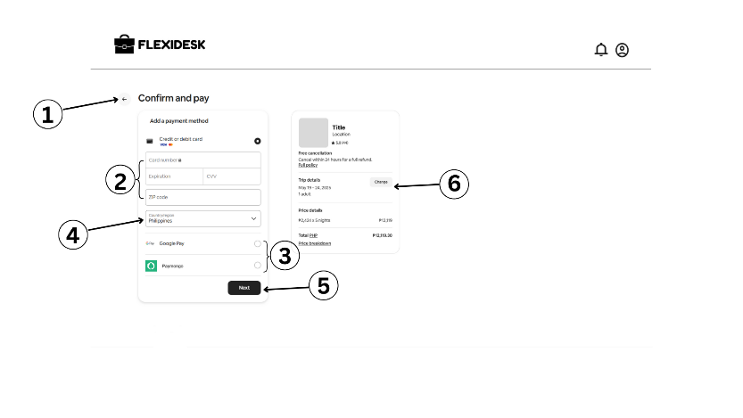

**Figure 18. Confirm and Pay Interface**

1. **Back Button**
2. **Credit/ Debit Card details**
3. **Radio Button**
4. **Country Drill Down**
5. **Next Button**
6. **Change button**

Figure in the next page a "Change reservation details" overlay. At the top (11), it indicates that this is part of the "Confirm and pay" process. Tabs for "Dates" and "Guests" are present (12), with the "Dates" tab currently selected, displaying a calendar for May and June 2025. The 19th to the 24th of May is highlighted (13, 14), corresponding to the dates shown in the previous image. A "Clear dates" option (15) and a "Save" button (16) are available.

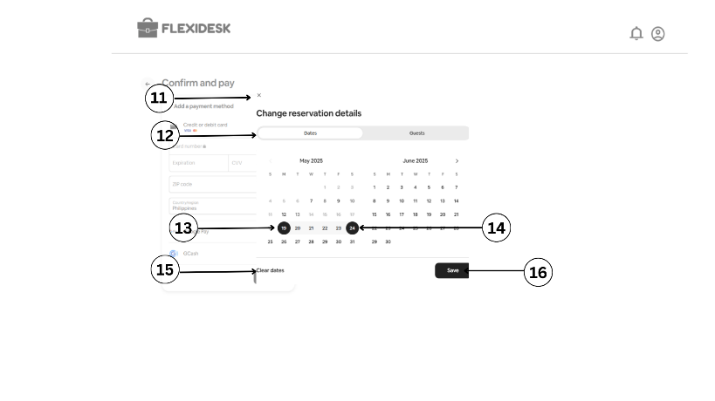

**Figure 19. Change Reservation Interface**

1. **Close Button**
2. **Dates Toggle**
3. **Start Toggle**
4. **End toggle**
5. **Clear dates**
6. **Save button**

Figure 20 below appears to be the homepage of the "FLEXIDESK" platform. A search bar with placeholders for "Where," "Check in," "Check out," and "Who" is prominently displayed. Below this, a category section shows various "Space" options. Listings of available spaces are shown as cards with placeholder images, titles, brief descriptions including location and distance, and a price per night (e.g., "$123 / night"). A heart icon for saving is on each card. At the top right, a profile icon with a dropdown menu (1) shows options to "Sign in" (2) and "Log in" (3). A map view button is also visible at the bottom.

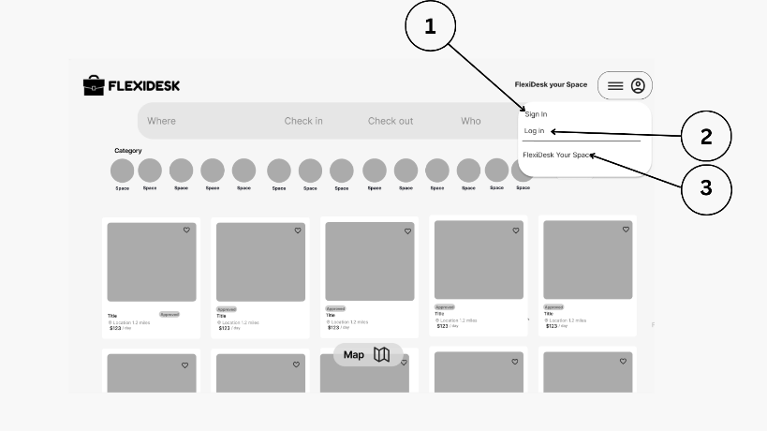

**Figure 20. Account Log-In or Sign-Up**

1. **Log in**
2. **Sign up**
3. **FlexiDesk Space**

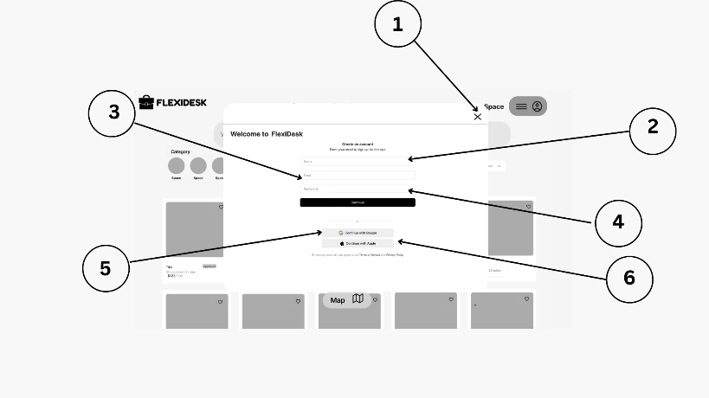 Figure 21 below shows a "Welcome to FlexiDesk" modal overlay on the homepage. It presents options to "Create an account" by entering an email and password (2) and clicking "Continue" (4). Alternatively, users can "Continue with Google" (5) or "Continue with Apple" (6). An "X" button to close the modal is at the top right (1), and the underlying homepage with category options (3) and space listings is partially visible.

**Figure 21. Sign-Up Interface**

1. **Close**
2. **Name**
3. **Email**
4. **Yes Link**
5. **Continue with Google**
6. **Continue with Apple**

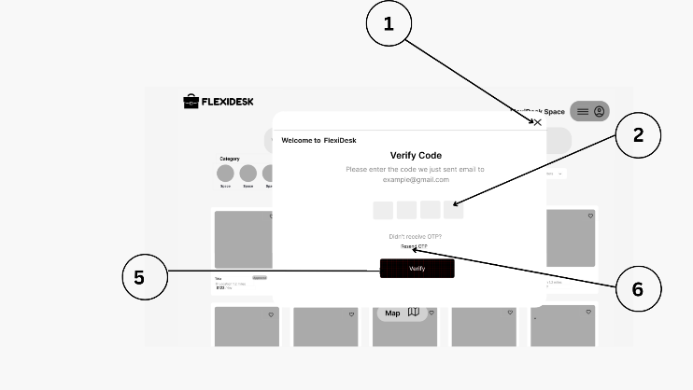 Figure 22 below displays a "Verify Code" modal, indicating that a code has been sent to the provided email address (example@gmail.com). Four input fields are shown for entering the verification code (2). Options to "Didn't receive OTP?" and "Resend OTP" are available. A "Verify" button (6) is present to proceed. The modal appears on top of the FlexiDesk homepage (5), with the close button visible at the top right (1).

**Figure 22. Verify Code Interface**

1. **Close**
2. **Input box**
3. **Resend**
4. **Verify**

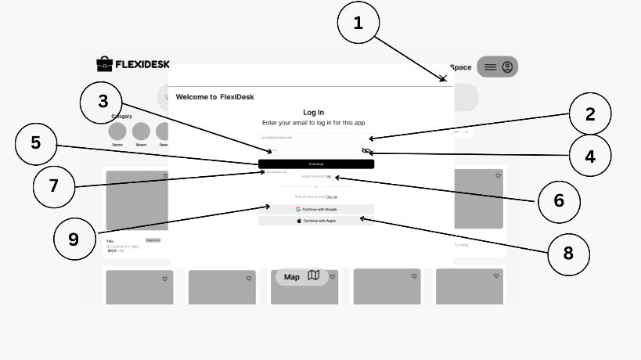 Figure 23 below shows a "Log In" screen within the "Welcome to FlexiDesk" modal. It prompts the user to "Enter your email to log in for this app" (2) with an input field provided. A "Continue" button (4) is available. Below, options to "Continue with Google" (6) and "Continue with Apple" (8) are shown. A link to "Forgot password?" (7) and a sign-up option "Don't have an account? Sign up" (9) are also present. The modal is displayed over the FlexiDesk homepage (5) with category options (3) and a close button at the top right (1).

**Figure 23. Log-In Interface**

1. **Close**
2. **Email**
3. **Password**
4. **Hide password**
5. **Confirm**
6. **Yes link**
7. **Sign up**
8. **Continue with google**
9. **Continue with apple**

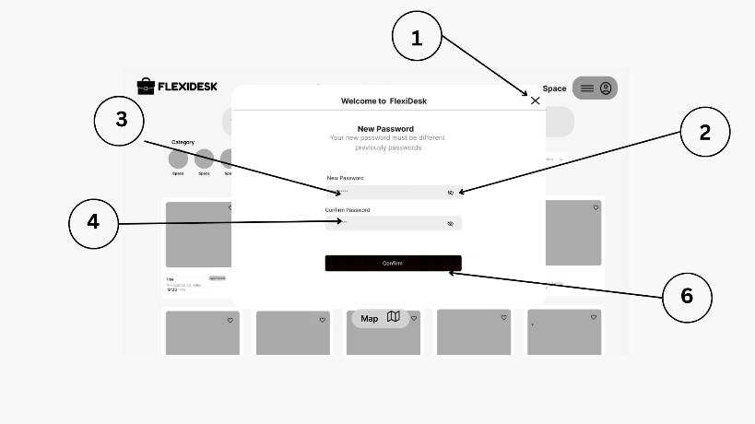Figure 24 below presents a "New Password" screen within the "Welcome to FlexiDesk" modal. It informs the user that "Your new password must be different from previously passwords." Input fields for "New Password" and "Confirm Password" (2) are provided, each with a "show/hide password" icon. A "Confirm" button (6) is available to set the new password. The modal overlays the FlexiDesk homepage (4), with category options (3) visible in the background and a close button at the top right (1).

**Figure 24. New Password Interface**

1. **Close**
2. **Show/Hide Icon**
3. **New**
4. **Confirm Password**
5. **Confirm Button**

Figure 25 in the next page displays a "Filters" modal on the FlexiDesk platform. It allows users to filter by "Type of place," with "Any type" currently selected and options like "Room" and "Entire Space" available (2). A "Price Range" slider (3) with minimum (₱2,900) and maximum (₱23,000+) values is shown. Below, a section for "Rooms" (4) offers specific room types like "Lounge," "Conference Room," "Call Room," "Private Room," "Pantry," and "Library." Options to "Clear All" filters (5) and "Show places" (6) are at the bottom. A close 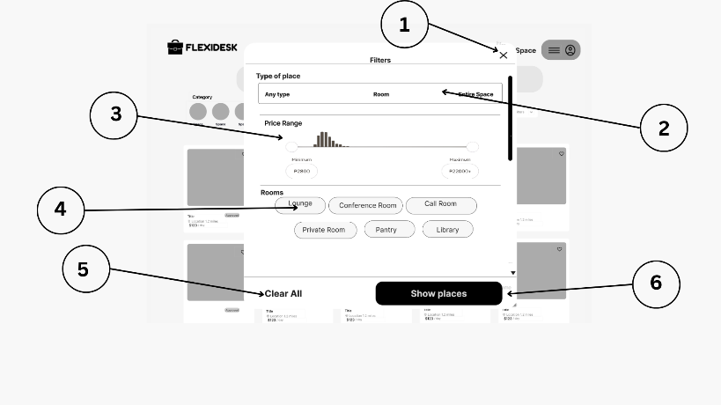button is at the top right (1).

**Figure 25. Filter Interface**

1. **Close**
2. **Type of Place toggle**
3. **Range button**
4. **Room Buttons**
5. **Clear All**
6. **Show Places**

Figure 26 in the next page shows an "Account" settings page on FlexiDesk. The user's name and email address are displayed at the top (3), with a "Go to profile" link. Several sections with icons and descriptions are available, including "Personal info" (4), "Login & security" (4), "Payments & payouts" (2), "Taxes" (5), "Notifications" (6), and "Privacy & sharing" (6). The FlexiDesk logo is at the top 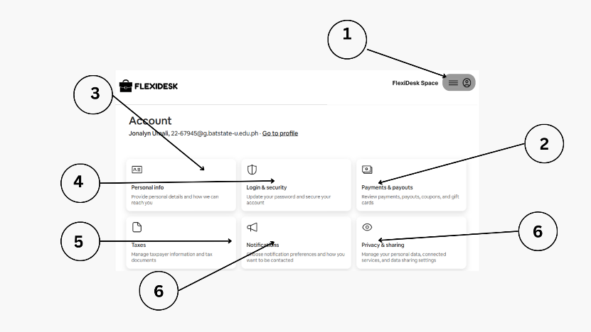left, and a profile icon with a menu is at the top right (1).

**Figure 26. Account Setting**

1. **Account Setting**
2. **Payment & Paymethods**
3. **Personal info**
4. **Login & Security**
5. **Taxes**
6. **Notification**
7. **Privacy & Sharing**

Figure 27 in the next page displays the "Personal info" section of a user's account settings on FlexiDesk. It shows various personal details such as "Legal name" (Jonelyn Umali) with an "Edit" option (1), "Preferred first name" (Not provided) with an "Add" option (2), "Email address" (partially obscured) with an "Edit" option, "Phone number" (partially obscured) with an "Edit" option and a note about using it for confirmed guests and Airbnb, "Identity verification" (Not started) with a "Start" option (3), "Address" (Not provided) with an "Edit" option, and 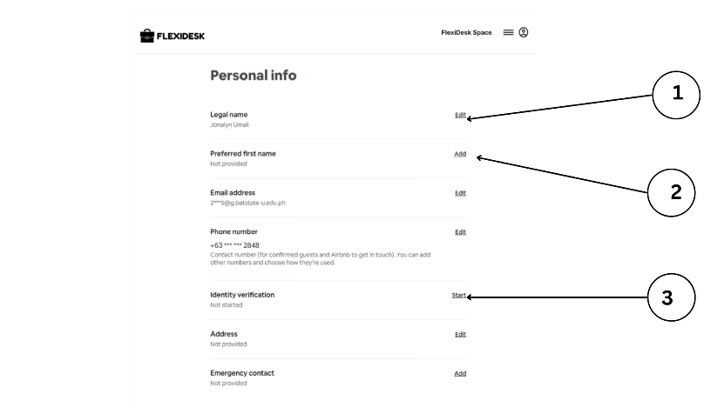"Emergency contact" (Not provided) with an "Add" option.

**Figure 27. Personal Info**

1. **Edit link**
2. **Add link**
3. **Start Link**

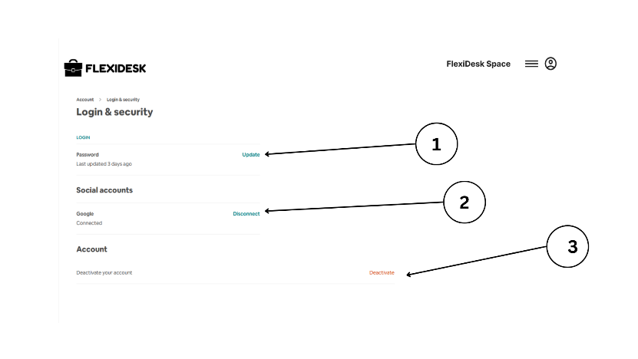Figure 28 below shows the "Login & security" settings page. Under the "Login" section, it indicates the "Password" was last updated 3 days ago and provides an "Update" option (1). The "Social accounts" section shows that "Google" is "Connected" with an option to "Disconnect" (2). Finally, under "Account," there's an option to "Deactivate your account" with a "Deactivate" button (3).

**Figure 28. Log-In and Security**

1. **Update button**
2. **Disconnect button**
3. **Deactivate Button**

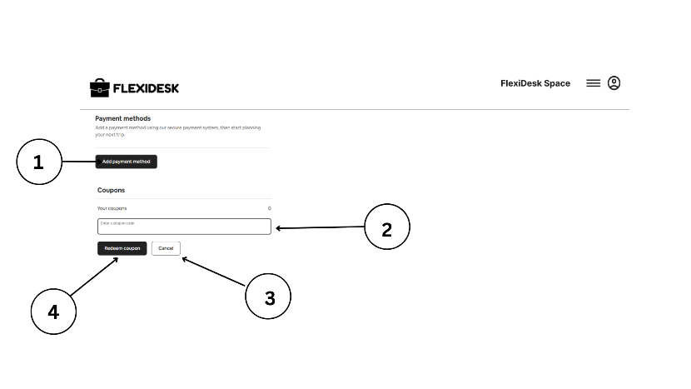 Figure 29 below displays the "Payment methods" section of the account settings. It informs the user that they can add a payment method using a secure payment system to start planning their next trip. An "Add payment method" button is prominently featured (1). Below, there's a "Coupons" section where users can view "Your coupons" (currently 0) and enter a coupon code in a provided field (2), with "Redeem coupon" (4) and "Cancel" (3) buttons available.

**Figure 29. Payment Method**

1. **Add payment method button**
2. **Coupon code box**
3. **Cancel button**
4. **Redeem button**

Figure 30 below is similar to the previous image but also includes a "Gift Card" section. It features an "Add gift card" button (2) below the "Payment methods" (1) section. The "Coupons" section remains the same, allowing users to enter a code (3) and either "Redeem coupon" (5) or "Cancel" (4).

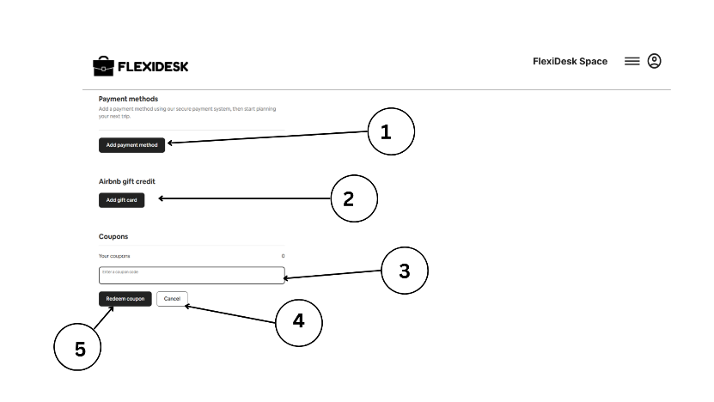

**Figure 30. Payment Method using Coupon**

1. **Add payment method button**
2. **Add gift card button**
3. **Coupon code box**
4. **Cancel button**
5. **Redeem button**

In thw next page, Figure 31 shows the "Payments & payouts" section of the account settings. It focuses on how a user will get paid, prompting them to "Add at least one payout method to tell us where to send your money." A "Set up payouts" button (1) is the primary call to action.

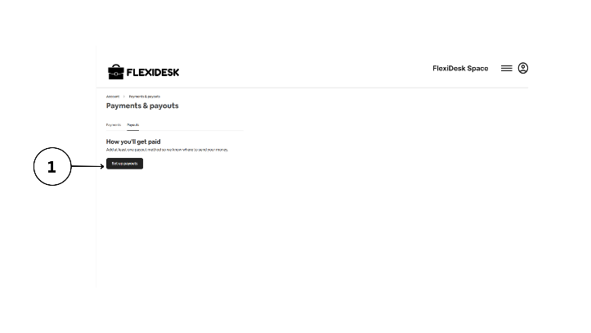

**Figure 31. Payment and Pay-outs**

1. **Set-up Pay-outs**

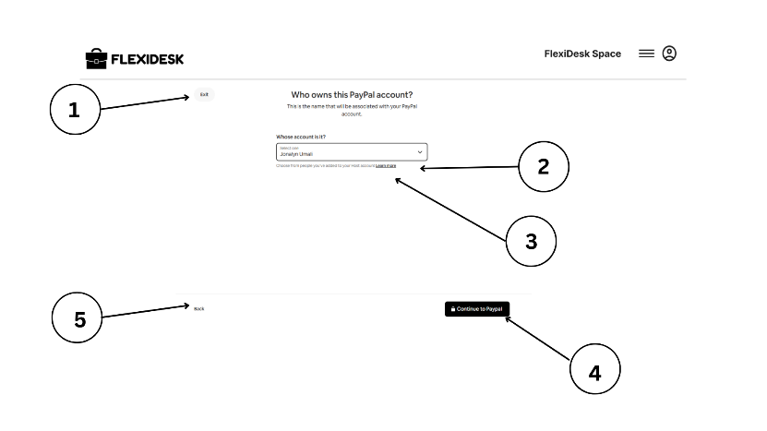 Figure 32 below appears to be part of a "Set up payouts" process, specifically for linking a PayPal account. The question "Who owns this PayPal account?" is asked, with a note clarifying that the name should match the name associated with the PayPal account. A dropdown menu (2) allows the user to select whose account it is, with "Jonelyn Umali" pre-selected (3). A "Continue to PayPal" button (4) is available, along with a "Back" button (5) and an "Exit" link (1).

**Figure 32. E-wallet Identification User**

1. **Exit button**
2. **Drop down**
3. **Learn more link**
4. **Continue button**
5. **Back**

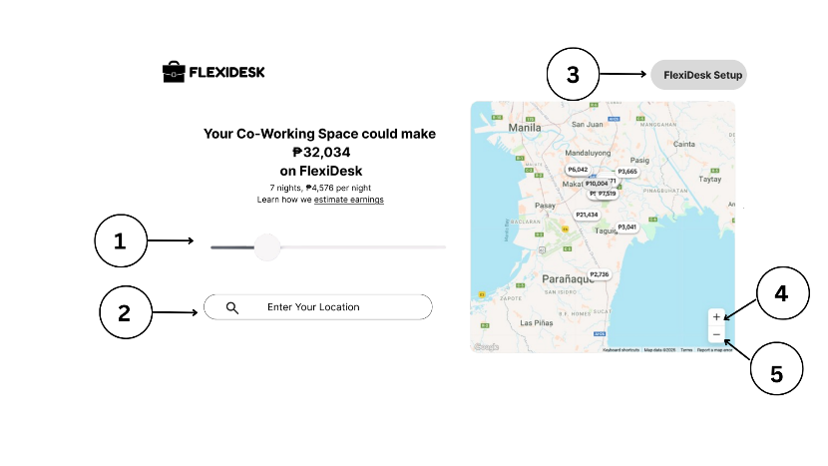 Figure 33 below seems to be a page for hosts on FlexiDesk, suggesting the earning potential of their co-working space. It states, "Your Co-Working Space could make ₱32,034 on FlexiDesk" based on "7 nights, ₱4,576 per night," with a link to "Learn how we estimate earnings." A slider (1) might be for adjusting parameters in the estimation. A search bar to "Enter Your Location" (2) is also present. On the right, a map of Manila and surrounding areas (3) shows potential earnings in different locations. Zoom controls (4) and a Google Maps interface (5) are visible. A "FlexiDesk Setup" button is at the top right.

**Figure 33. FlexiDesk Your Space**

1. **Range toggle**
2. **Search bar**
3. **Close**
4. **Zoom –in Button**
5. **Zoom-out Button**

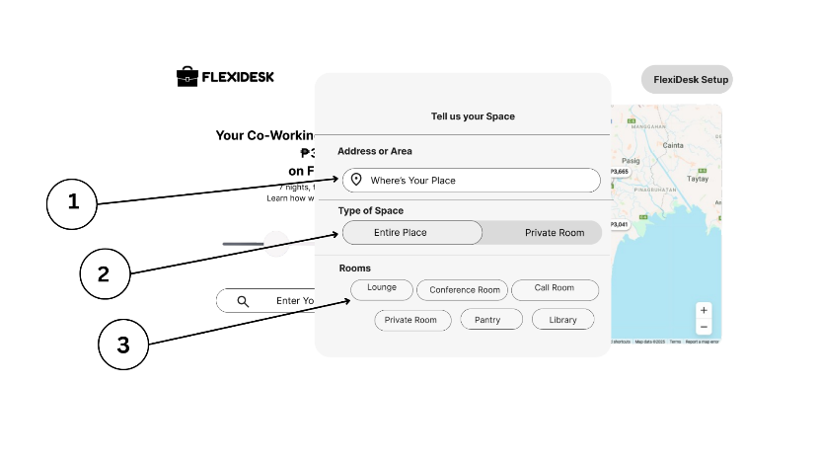 Figure 34 below shows a "Tell us your Space" modal, likely part of the FlexiDesk setup process for hosts. It asks for the "Address or Area" with a field showing "Where's Your Place" (3) and a map icon. It also asks for the "Type of Space," with "Entire Place" and "Private Room" as selectable options (1), and for specific "Rooms" available, such as "Lounge," "Conference Room," "Call Room," "Private Room," "Pantry," and "Library" (2).

**Figure 34. Tells us your Space**

1. **Location**
2. **Space type toggle**
3. **Room Type Buttons**

Figure 35 in the next page appears to be a dashboard for a host on FlexiDesk. It welcomes the owner (1) and mentions that "Guests can reserve your place 24 hours after you publish—here's how to prepare." A "Your Next Step" section (3) provides a series of actions for the host to take, including "Set up the Calendar" (6), "Cancellations Policy," "Space Rules," "Offer Promotions," "Check Out Instructions," and "Instant Book Reservations Reviewed." A navigation bar at the top includes "Today," "Calendar" (2), "Listings," "Messages" (4), and a "Menu" (5). Notification and profile icons are also visible.

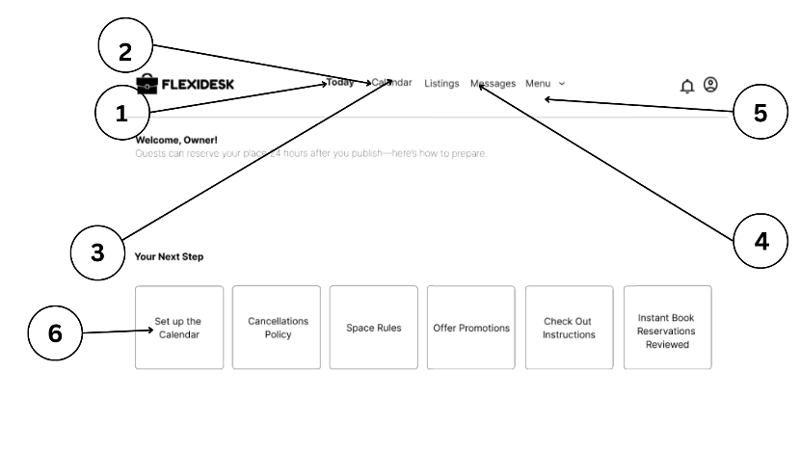

**Figure 35. Space Owner Dashboard**

1. **Today tab**
2. **Calendar**
3. **Listings**
4. **Messages**
5. **Menu dropdown**
6. **Select box**

In the next page, Figure 36 is a similar host dashboard, but with the "Menu" dropdown expanded (1). The options in the menu include "Earnings" (2), "Create new listing" (3), "Reservations," and "Guidebooks" (4). The rest of the dashboard remains the same, showing the welcome message and the "Your Next Step" actions.

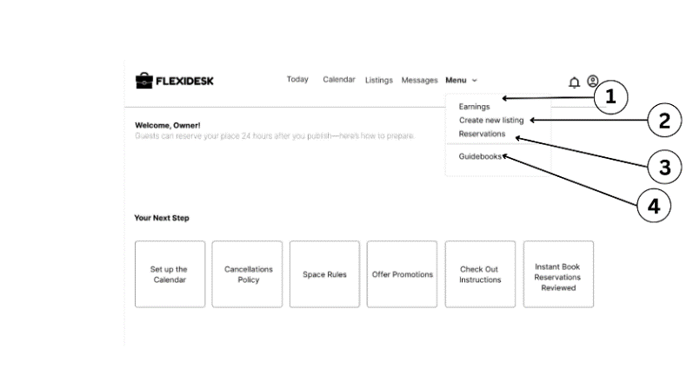

**Figure 36. Menu Interface**

1. **Earnings**
2. **Create new listing**
3. **Reservations**
4. **Guidebooks**

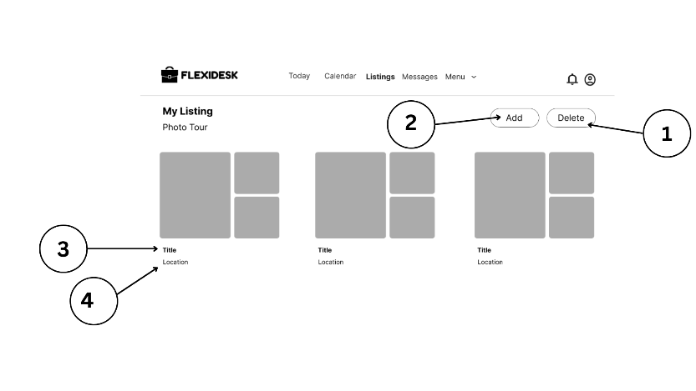 Figure 37 below shows the "My Listing" section, specifically the "Photo Tour." It displays placeholders for listing photos in a grid layout. Options to "Add" (2) more photos and "Delete" (1) existing ones are available. Below each photo placeholder, there's space for a "Title" (3) and "Location" (4), suggesting these details can be associated with each image in the photo tour.

**Figure 37. My Listing**

1. **Delete button**
2. **Add button**
3. **Title label**
4. **Location label**

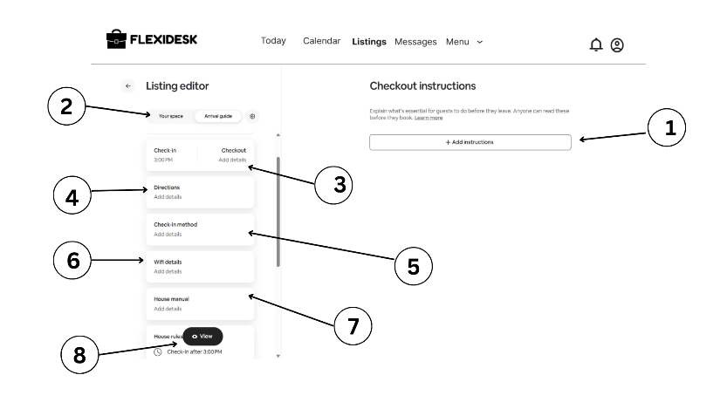 Figure 38 below presents the "Listing editor," focusing on "Checkout instructions" (1). It prompts the host to "Explain what's essential for guests to do before they leave. Anyone can read these before they book." An "+ Add Instructions" button is the call to action. On the left, a navigation panel (2) for the listing editor is visible, with sections for "Your space," "Arrival guide," "Check-in" (3) with a time of "3:00 PM," "Checkout" (3) with an option to "Add details," "Directions" (4), "Check-in method" (5), "Wifi details" (6), "House manual" (7), and "House rules" (8).

**Figure 38. Check Out Instructor of Listing Editor**

1. **Add instruction button**
2. **Toggle of your space and arrival guide**
3. **Duration**
4. **Directions check in method**
5. **Check in method**
6. **WiFI details**
7. **House manual**
8. **View**

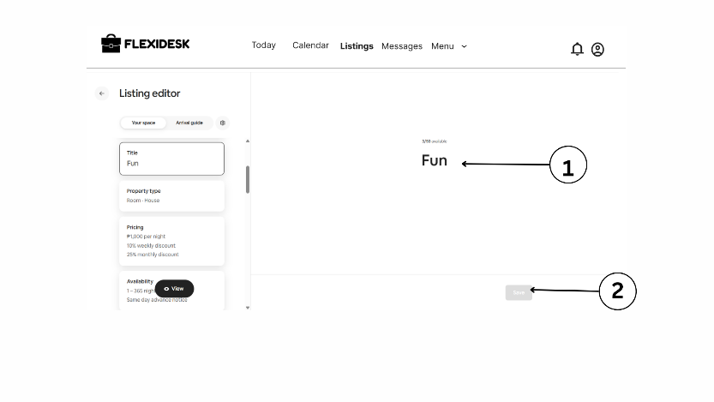 Figure 39 below continues within the "Listing editor," now showing the "Your space" section. A field for the "Title" is filled with "Fun" (1), and the "Property type" is listed as "Room - House." Pricing details show "₱1,000 per night" with potential discounts for weekly and monthly stays. Availability is listed as "1 – 365-night days" with "Same day check-in allowed." A "Next" button (2) suggests this is part of a multi-step editing process.

**Figure 39. Co-Working Space Title in Listing Editor**

1. **Editable title**
2. **Save button**

Figure 40 in the next page displays the "Create a guidebook" section within the "Listing editor." It encourages the host to "Create a guidebook to easily share local tips with guests." An add icon (1) suggests the user can add entries to their guidebook. Two example images are shown, hinting at the type of local information that can be included.

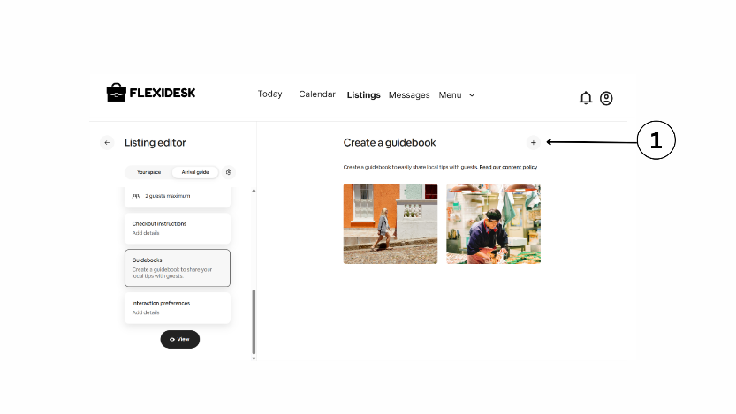

**Figure 40. Create Guidebook**

1. **Add Button**

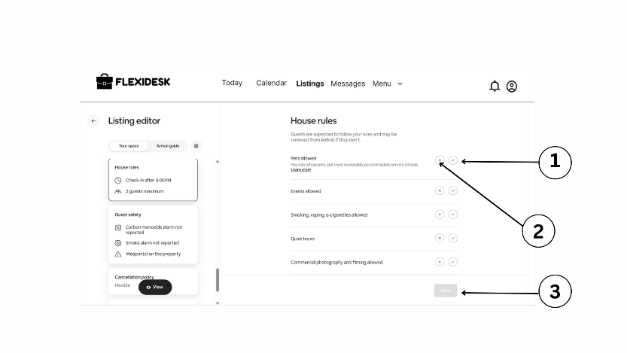 Figure 41 below shows the "House rules" section of the "Listing editor." It explains that "Guests are expected to follow your rules and may be removed from Airbnb if they don't." Checkboxes are provided for various rules, such as "Pets allowed" (currently unchecked with an info icon) (1), "Events allowed" (unchecked), "Smoking, vaping e-cigarettes allowed" (unchecked), "Quiet hours" (unchecked), and "Commercial photography and filming allowed" (unchecked) (2). A "Save" button (3) is available to apply any changes.

**Figure 41. House Rules**

1. **Check button**
2. **X- Mark Button**
3. **Save button**

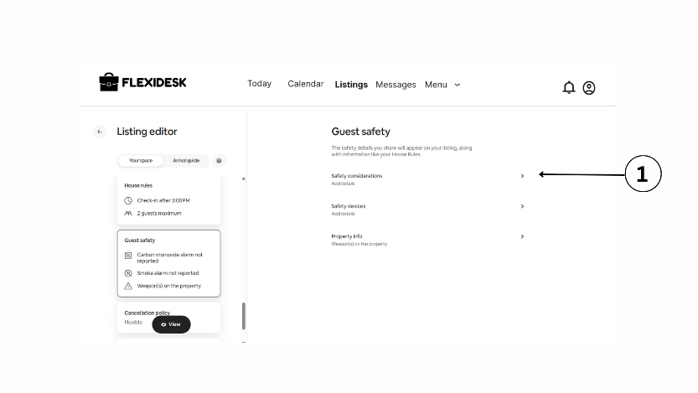 Figure 42 below presents the "Guest safety" section of the "Listing editor." It explains that "This safety details you share will appear on your listing, along with important local emergency numbers." Options for "Safety considerations" (Add details), "Safety devices" (Add details), and "Property info" (Weapons on the property) are listed, each with a right arrow indicating further details can be added or viewed (1).

**Figure 42. Guest Safety**

1. **Show button**

Figure 43 below displays the "Cancellation policies" section of the "Listing editor." It informs the host to "Review the full policies in the Help Center." For "Short-term stays" (up to 28 nights), the current policy is "Flexible" with an "Edit" option (1). A "Non-refundable option" toggle is available with an explanation of its implications (2). A section for "Long-term stays" (28+ nights) also shows a "Your policy" as "Firm Long Term" with an "Edit" option.

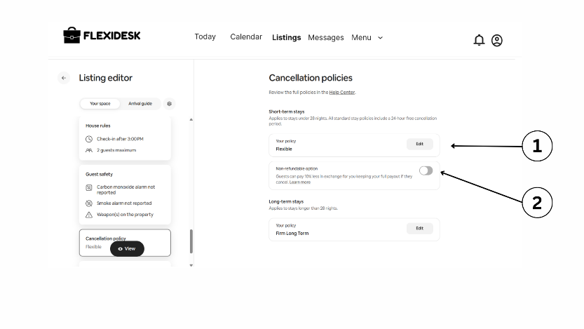

**Figure 43. Cancellation Policies**

1. **Edit Button**
2. **Non- refundable toggle**

Figure 44 in the next page shows the "Availability" settings within the "Listing editor." It states, "These settings apply to all nights, unless you customize them by date." Options for "Trip length" include setting a “Minimum night” (currently 1) (1) and "Maximum nights" (currently 365) (9). "Advance notice" (10) asks "How much notice do you need before a guest's booking and their arrival?" with "Same day" selected. "Guests can book on the same day you check-in and until this time:" (11) shows a dropdown with "6:00 AM" selected. The "Availability" section also shows "365night days" selected (5). The left panel shows the "Property type" (3), "Pricing" (4), and "Number of guests" (6) settings. A "Description" field (7) and an option to "View" (8) are also present. A "Save" button (12) is at the bottom right.

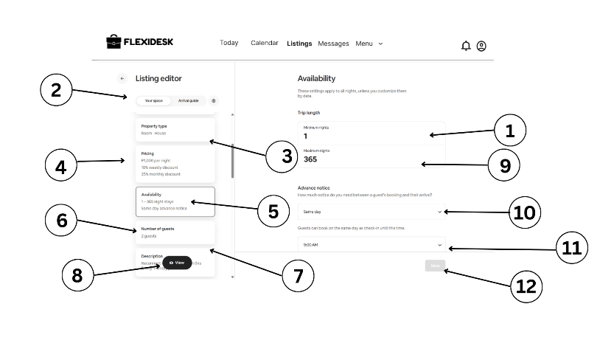

**Figure 44. Availability**

1. **Editable miniimum lengths**
2. **Your space and Arrival guide toggle**
3. **Property type selector**
4. **Availability selector**
5. **Number of Guests**
6. **View**
7. **Editable maximum lengths**
8. **Same day dropdowm**
9. **Check in time dropdown**
10. **Same**
11. **Drop down time**
12. **Save Button**

Figure 45 in the next page focuses on the "Number of guests" setting within the "Listing editor." It displays a visual representation of "How many guests can fit comfortably in your space?" with the number "2" shown on both sides of a graphic depicting two people (1, 2), indicating a capacity of 2 guests.

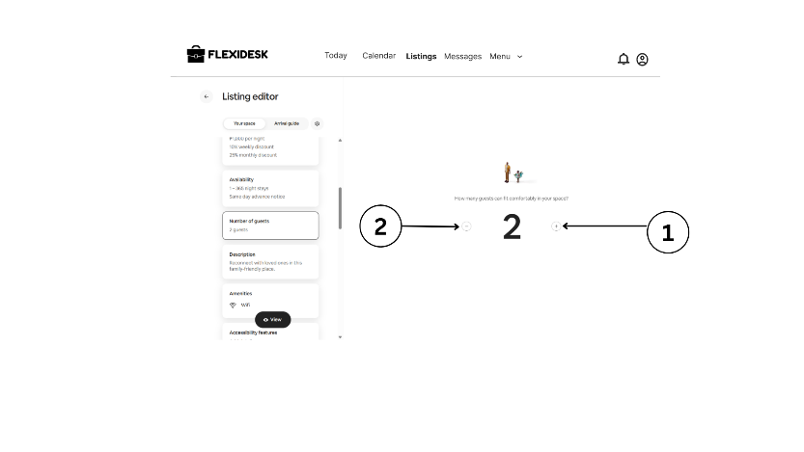

**Figure 45. Number of Guest**

1. **Decrease button**
2. **Increase button**

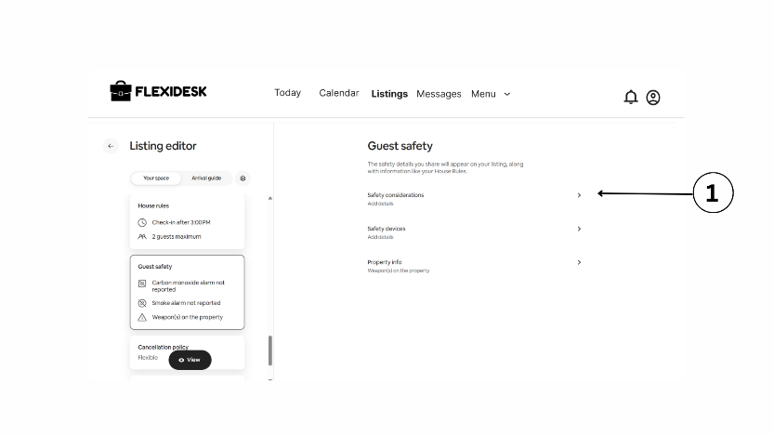 Figure 46 below shows the "Accessibility features" section of the "Listing editor." It lists various accessibility features such as "Disabled parking spot," "Step-free path to guest entrance," "Step-free access," "Guest entrance wider than 32 inches," "Swimming pool/hot tub hoist," and "Ceiling or mobile hoist." Each feature has a "+" icon (1) next to it, suggesting the host can add details or confirm the availability of these features.

**Figure 46. Accessibility Features**

1. **Add button**

Figure 47 below shows the "Property type" section within the "Listing editor." It asks "What kind of space are you listing?" with "House" selected in a dropdown (1). Below, "Property type" is specified as "Home" (2). Further down, "Listing type" offers options like "Room" (3). Information clarifies that "Guests have their own room for sleeping. Other spaces might be shared." The host is asked "How many rooms in the building?" with "1" entered, and "Which floor is the listing on?" also with "1" entered. A field for "Your unit" (5) is present. Finally, a dropdown for "Property size" allows selection between "Unit" and "Square feet/Square meters" (5), with a "Save" button (6) at the bottom.

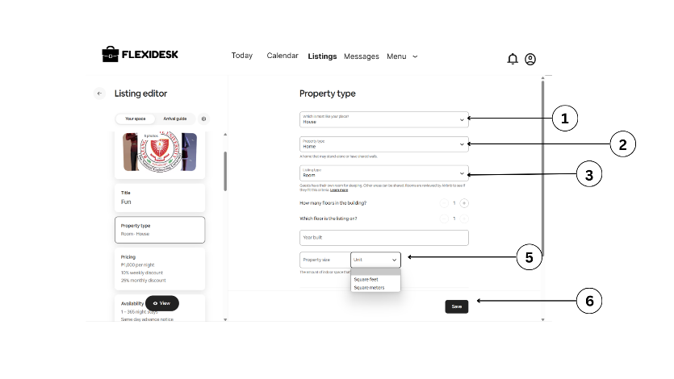

**Figure 47. Property Type**

1. **Place dropdown**
2. **Property type dropdown**
3. **Listing type dropdown**
4. **Increase Button**
5. **Dropdown for property size**
6. **Save button**

Figure 48 below displays the "Description" section of the "Listing editor" (1). It provides several fields for the host to describe their property, including "Listing description" (with example text "Reconnect with loved ones in this family-friendly place"), "Your property" ("Add details"), "Guest access" ("Add details"), "Interaction with guests" ("Add details"), and "Other details to note" ("Add details"). Each field has a pencil icon next to it, indicating it can be edited.

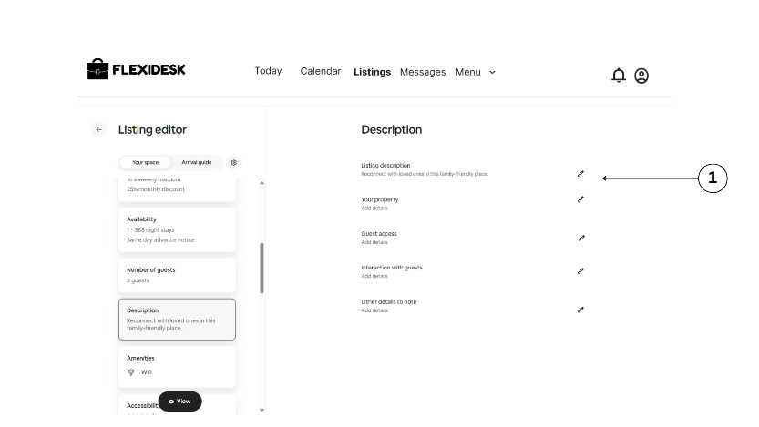

**Figure 48. Description of Co-Working Space**

1. **Edit Symbol**

Figure 49 below shows the "About the host" section in the "Listing editor." A profile picture placeholder with the initial "J" is visible, along with an "Add" button to upload a photo (1). The host's name "Jonelyn" and the year they started hosting "Started hosting in 2025" are displayed. Several prompts encourage the host to share information, such as "The information you share will be used across Airbnb to help other guests and Airbnb get to know you" (introductory text), "Where I've always wanted to go" (2), "My work" (4), "My most useless skill" (5), "Pets" (not 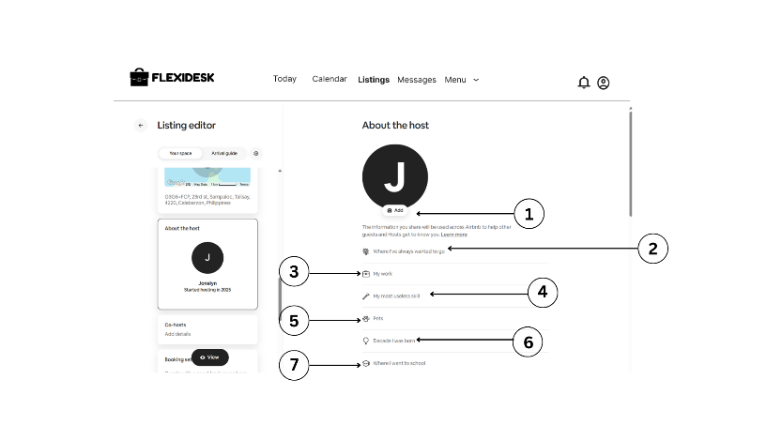visible in this view), "Decade I was born" (6), and "Where I went to school" (7).

**Figure 49. About the Host**

1. **Upload Image for Profile**
2. **Dream Travel Edit button**
3. **Work**
4. **Useless skill**
5. **Pets**
6. **Decade that owner as born**
7. **Graduate school**

Figure 50 in the next page continues the "About the host" section. Building upon the previous image, it shows more prompts for the host to personalize their profile. These include "My work" (8), "My most useless skill" (9), "Pets" (10), "Decade I was born," "Where I went to school" (8), "My favorite song in high school" (8), "I spend too much time..." (9), "My fun fact" (10), "My biography title would be..." (11), "I'm obsessed with..." (12), and "Languages I speak" (13).

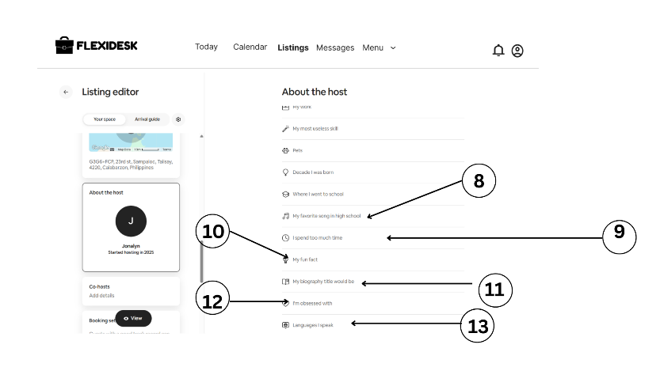

**Figure 50. About the Host**

1. **Fave high school songs**
2. **Hobby**
3. **Fun fact**
4. **Biography title**
5. **Obsessed with**
6. **Languages**

In the next page, Figure 51 further expands on the "About the host" section, now focusing on "About you." A text area is provided for the host to write something fun and personal (14), with an "Add photo" option. A section for "Where you've been" (15) allows the host to indicate places they've traveled, with icons for different types of trips (e.g., world, sun, plane). Finally, "What you're into" (16) lets the host add interests by clicking "+" icons, with "Add interests" text below.

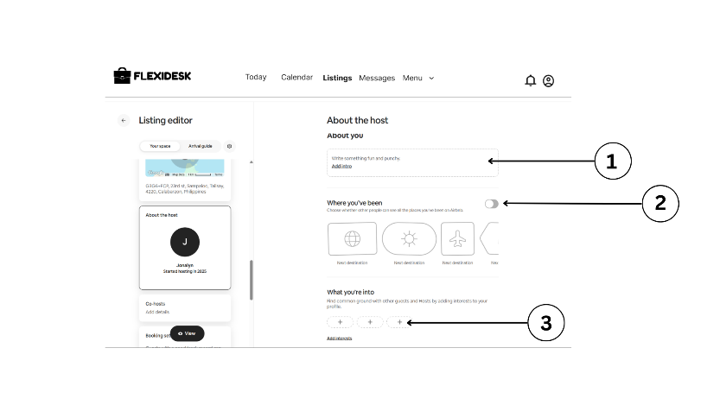

**Figure 51. About the Host**

1. **Add intro**
2. **Where you've been toggle**
3. **Add button to adding interest to you**

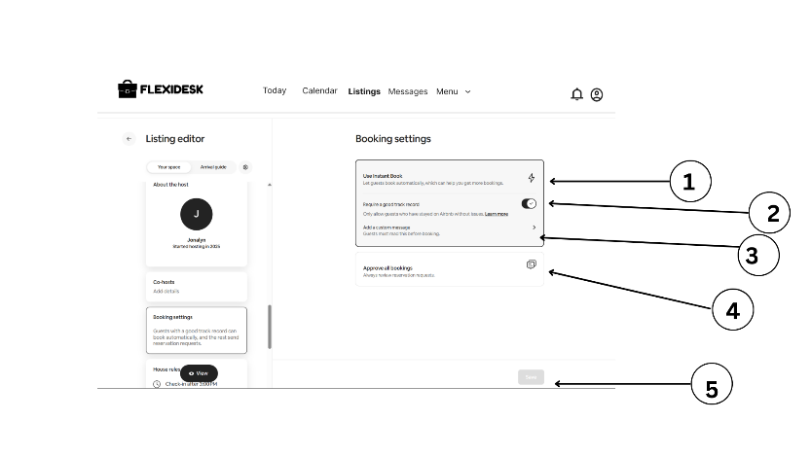 Figure 52 below displays the "Booking settings" section of the "Listing editor." A toggle for "Instant Book" (1) is shown, allowing guests to book automatically. A toggle for "Require guests to read and agree to your House Rules" (2) is also present. An option to "Add a booking message" (3) is available. A section for "Approved guest bookings" (4) is shown with a chat bubble icon. A "Save" button (5) is at the bottom.

**Figure 52. Booking Setting**

1. **Instant Book**
2. **Toggle for track record**
3. **Custom messages**
4. **Serious custom messages**
5. **Approve all bookings messages**

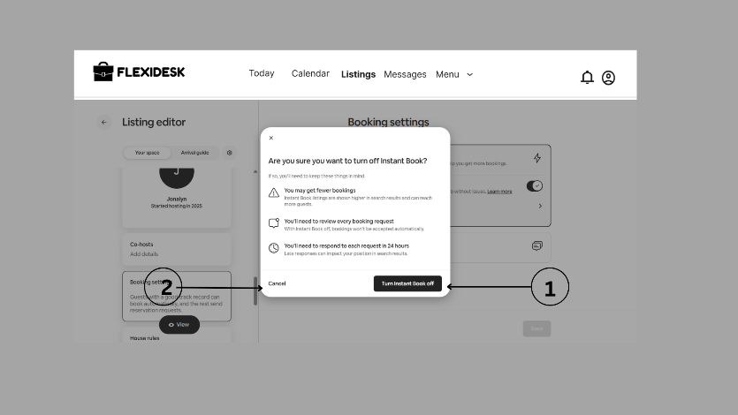 Figure 53 below shows a confirmation modal that appears when a host attempts to turn off "Instant Book" in the "Booking settings." The question "Are you sure you want to turn off Instant Book?" is displayed, along with reasons why it might not be beneficial ("You may get fewer bookings," "You'll need to review every booking request," "You'll need to respond to each request in 24 hours"). Options to "Cancel" (2) or "Turn Instant Book off" (1) are provided.

**Figure 53. Instant Book Off**

1. **Instant Book Button**

Figure 54 below shows the "Reservations" section of the host dashboard. Filters (1) are available to "Select a listing" and to choose "Reservations that start or end within the following dates" (2), with a calendar interface (3, 4) allowing the host to select a date range in May 2025. An "Apply" button (5) is present to apply the date filter. Tabs for "Upcoming," "Completed," "Cancelled," and "All" 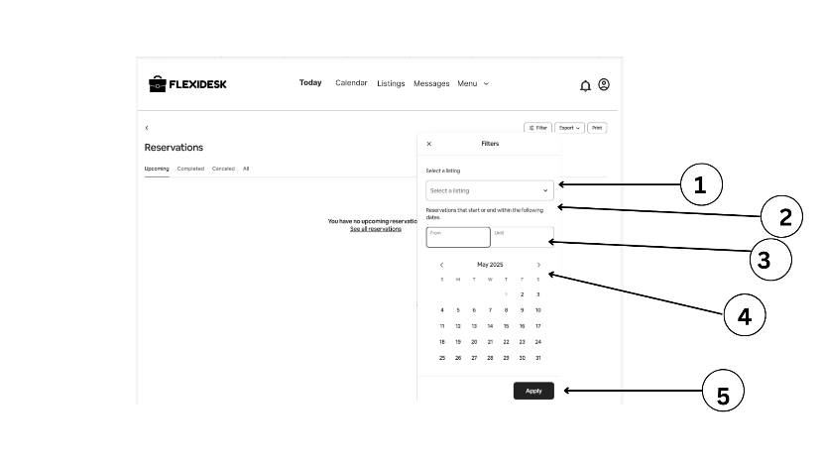reservations are visible at the top.

**Figure 54. Reservation Filter**

1. **Listing drops down**
2. **Duration of reservation toggle**
3. **Generated calendar**
4. **Apply button**

Figure 55 below displays the "Safety considerations" subsection within "Guest safety" in the "Listing editor" (1, 2). It presents a list of safety considerations with explanations and toggles or options to indicate their presence or absence. Examples include "Not good for children 0-2," "Not good for infants under 2," "Stairs that aren't well-lit or don't have handrails," "Potentially dangerous animals present," "Some spaces are shared," and "Carbon monoxide detector isn't working." Each item has an arrow or toggle (3, 4) to provide more detail or mark its status. "Cancel" (6) and "Save" (5) buttons are at the bottom.

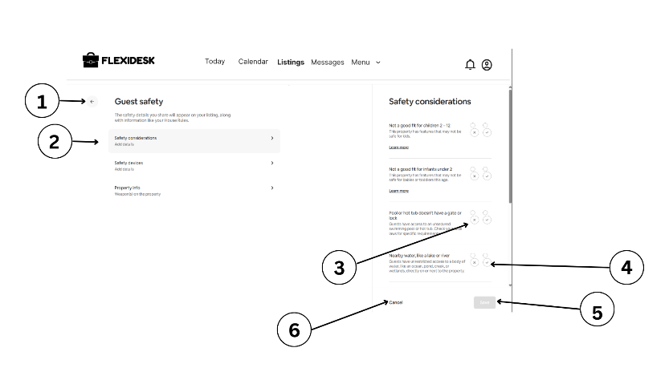

**Figure 55. Safety Considerations**

1. **Back button**
2. **Safety consideration selector**
3. **X-button**
4. **Check button**
5. **Cancel button**

Figure 56 below shows the "Calendar" view for a host in 2025. Months from April to September are partially visible, with days and potentially prices or availability indicators. On the right, a section allows the host to manage pricing and fees, including "Cleaning fee" (1) with a per-stay amount of "₱0" and an edit option, "Amount per short stay" (2) with an "Add" option to attract guests booking for 1 or 2 nights by setting a lower cleaning fee, "Pet fee" (3) with a per-stay amount of "₱0" and an edit option, and "Extra guest fee" (4) with "₱0" per guest, per night after 1 guest, and an edit option. A "View" dropdown (5) is at the top.

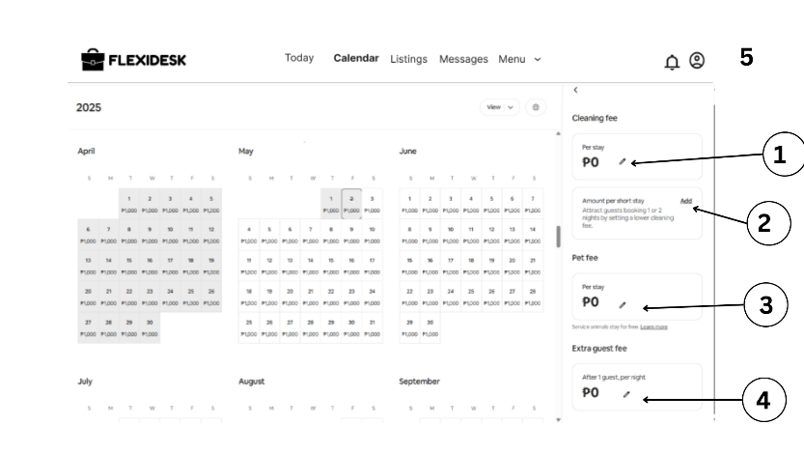

**Figure 56. Listing Fees**

1. **Per stay Edit Symbol**
2. **Add button**
3. **Pet fee per stay Edit Symbol**

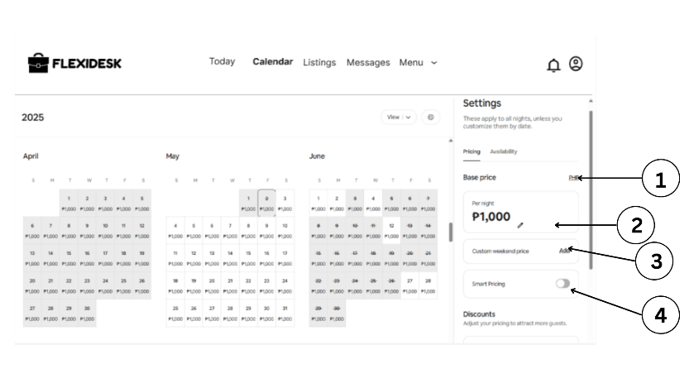 Figure 57 below shows the "Calendar" view with a "Settings" panel open, specifically under the "Pricing" tab. It indicates that "These settings apply to all nights, unless you customize them by date." The "Base price" (1) is set to "₱1,000" per night, with an edit option (2). An option to "Add" a "Custom weekend price" (3) is available. A toggle for "Smart Pricing" (4) is turned off. Below, a "Discounts" section encourages the host to "Adjust your pricing to attract more guests."

**Figure 57. Price Listing Settings**

1. **Unit Cost Sign**
2. **Per night unit cost editable**
3. **Add button of custom weekend price**
4. **Smart pricing toggle**

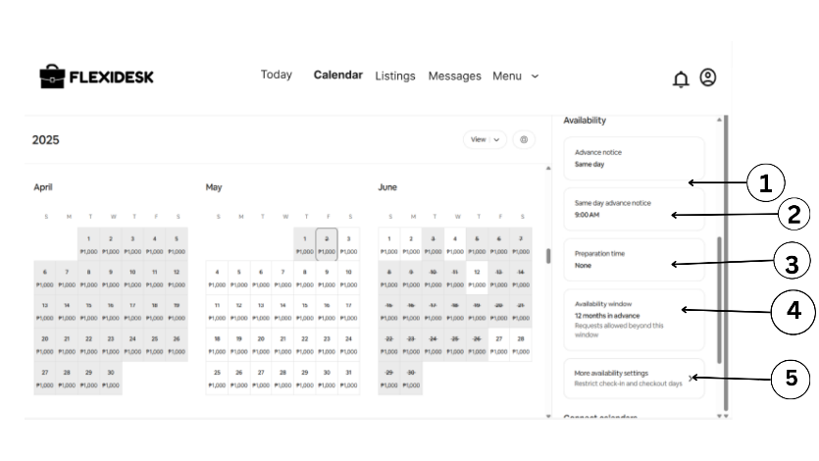 Figure 58 below displays the "Calendar" view with the "Settings" panel now showing the "Availability" tab. "Advance notice" is set to "Same day" (1). "Same day advance notice" has a cutoff time of "9:00 AM" (2). "Preparation time" is set to "None" (3). "Availability window" is set to "12 months in advance" with a note that "Requests allowed beyond this window." (4). A link to "More availability settings" (5) suggests further customization options for check-in and checkout days.

**Figure 58. Availability**

1. **Same day button**
2. **Preparation time**
3. **Availability**
4. **12 months in advance**
5. **More availability settings**

Figure 59 below continues the "Calendar" "Settings" panel under "Availability." "Preparation time" is again shown as "None" (6). The "Availability window" is "12 months in advance" (7). A link to "More availability settings" to restrict check-in and checkout days is present (8). Finally, a "Connect calendars" section allows the host to "Sync all of your hosting calendars so they automatically 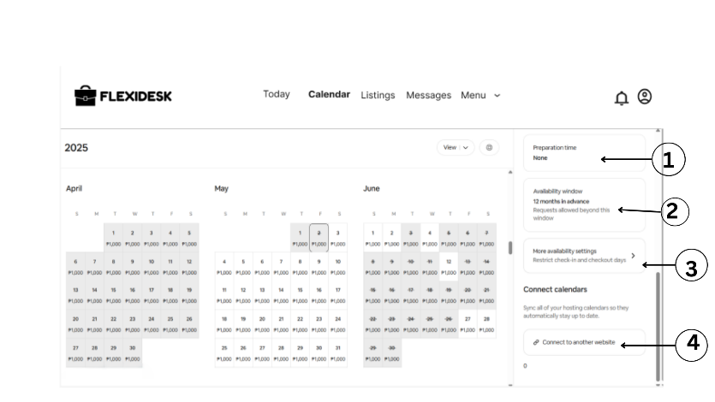stay up to date," with an option to "Connect to another website" (9).

**Figure 59. Availability**

1. **Advance notice**
2. **Preparation time selector**
3. **Availability window**
4. **More availability settings**

Figure 60 in the next page shows the "Calendar" view with a "Last-minute discount" setting open. It explains that this is "For reservations booked 1 to 28 days before arrival." A slider allows the host to set the number of "Days before arrival" (1). A "Discount" percentage can be entered (2), currently at "0%." "Save" (3) and "Cancel" (4) buttons are available.

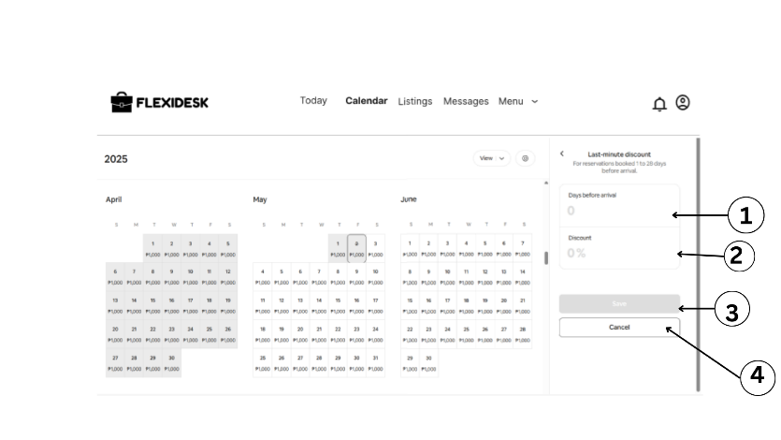

**Figure 60. Last Minute Discount**

1. **Days before arrival**
2. **Discount Editable**
3. **Save**
4. **Cancel**

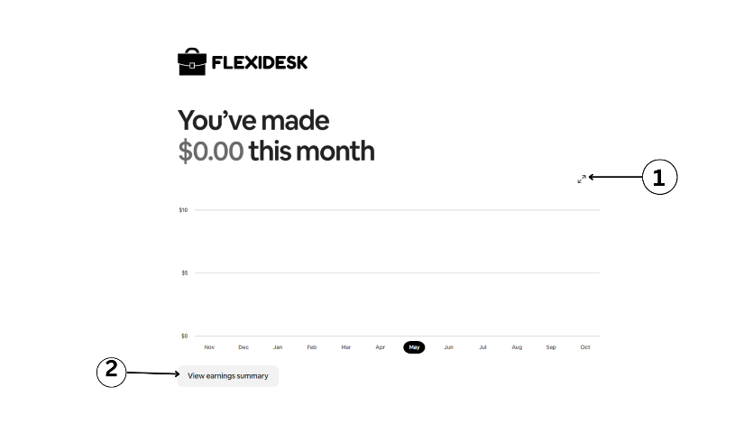 Figure 61 below displays the "Earnings" section of the host dashboard. It shows "You've made $0.00 this month" in a prominent font. A simple line graph displays potential earnings over several months, with "May" highlighted on the x-axis (1). A button to "View earnings summary" (2) is below the graph.

**Figure 61. Earning Dashboard**

1. **Monthly income dashboard**
2. **View earning summary button**

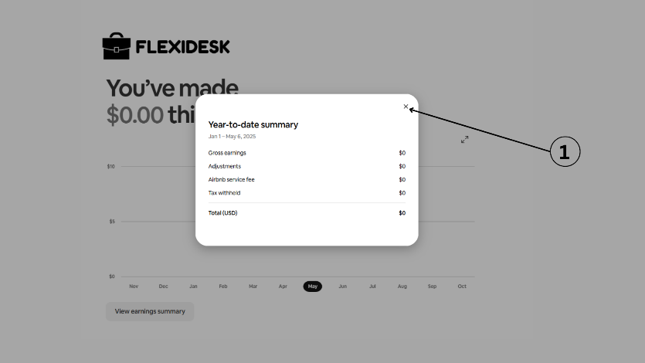 Figure 62 below shows a "Year-to-date summary" modal that appears after clicking "View earnings summary." It displays earnings from "Jan 1 - May 6, 2025," with "Gross earnings," "Adjustments," "Airbnb service fee," "Tax withheld," and "Total (USD)" all listed as "$0." An "X" button (1) allows the user to close the summary.

**Figure 62. Year to Date Summary**

1. **Choose Button**

Figure 63 below appears to be an administrator dashboard for FlexiDesk. Key metrics are displayed in boxes, including "TOTAL USERS" (123) (7), "VERIFIED USERS" (93) (8), "LISTED Coworking Space" (308) (6), and "PENDING VERIFICATION" (30) (5). Charts showing "Monthly Signups" and another metric are also visible. A "Top Owners" list displays names and email addresses (4). A search bar (3) and notification/profile icons (1, 2) are at the top. A left sidebar (9) offers navigation options like "Discover," "Dashboard," "User Management," "Analytics & Insights," "Security & Compliance," and "Settings."

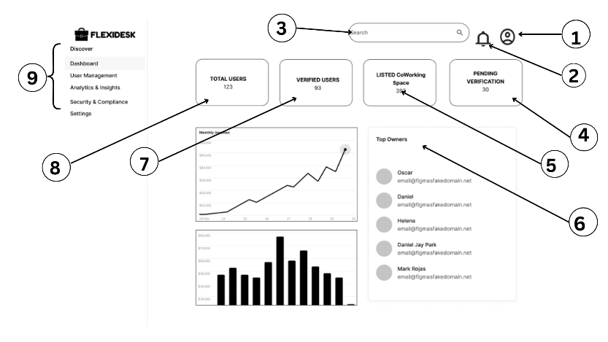

**Figure 63. Admin Dashboard**

1. **Account Settings**
2. **Notification**
3. **Search Bar**
4. **Pending verification statistics card**
5. **Listed CoWorking Space card**
6. **Top owners ranking**
7. **Verified user card**
8. **Total user card**
9. **Navigation bar**

Figure 64 in the next page shows the "User Management" section of the admin dashboard. It features a "Pending List" (6) of workspaces with columns for "Workspace Name," "Business License Upload," "Contact Info," "Fraud Risk Score (%)", and "Action." Actions include checkmarks and an "X" for approval/rejection, and a "Request More Info" link (1, 2, 3). Below, a "Flagged List" (7) shows similar columns with an "Action" to "Black List" or "Deactivate" (4, 5).

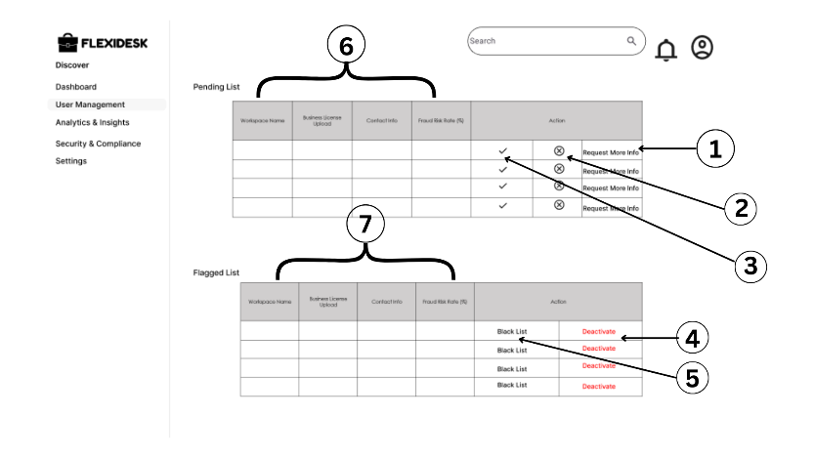

**Figure 64. User Management**

1. **Request more info button**
2. **Decline button**
3. **Accept but**
4. **Deactivate button**
5. **Blacklist button**
6. **Pending list information**
7. **Flagged list information**

Figure 65 below displays the "Analytics & Insights" section of the admin dashboard, specifically "Charts & Metrics" (4). A table shows "Top Yearly Rates of Co-Working Spaces" with columns for "Source," "Sessions," and "Change." Below are charts for "Monthly Incomes." On the right, a "Campaign Manager" offers options to "Create Ads" (1), "Set Budget" (2), and "Select Co-Workspaces" (3).

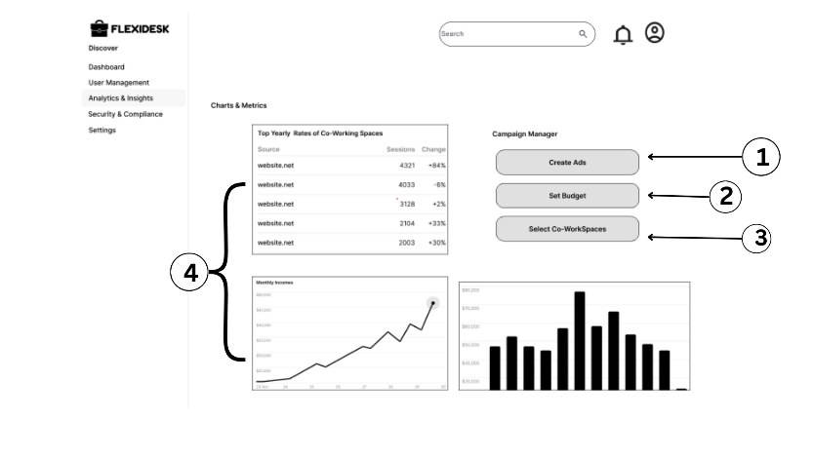

**Figure 65. Analytics and Insights**

1. **Create Ads Button**
2. **Set Budget Button**
3. **Select CoorkSpaces Button**
4. **Charts**

Figure 66 below shows a "Create Ads" modal, likely accessed from the "Campaign Manager." It includes fields to enter an "Ad Title" (1), select a "Workspace to Feature" from a dropdown (2), "Upload Image" for the "Ad Banner Image" (3), and set "Start Date" and "End Date" (5). Buttons to "Preview Ad" (5) and "Submit Ad" (6) are available. A chart from the "Analytics & Insights" section is visible in the background (4).

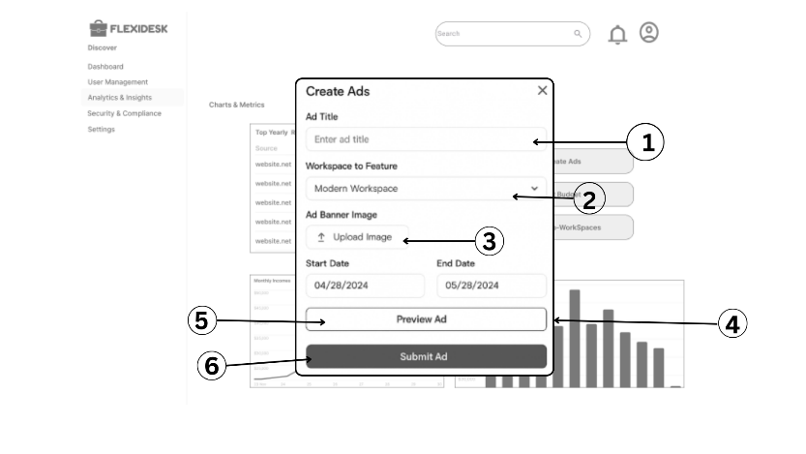

**Figure 66. Create Ads**

1. **Ad Title**
2. **Workspace Feature**
3. **Upload Image**
4. **Duration**
5. **Preview Ad**
6. **Submit Ad**

Figure 67 in the next page shows a "Set Budget" modal, likely for an advertising campaign managed within the admin dashboard. It has fields for "Daily Budget" (1) and "Total Campaign Budget" (2), which is "auto-calculated based on duration." An "Estimated Reach" (3) is displayed with a note that it's a "dynamic projection as you input values." A toggle for "Spending Cap" (4) is turned on. A "SAVE" button (5) is at the bottom.

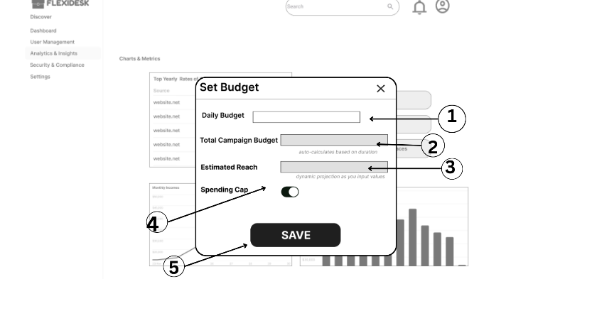

**Figure 67. Set Budget**

1. **Daily budget text box**
2. **Auto generated total camping budget**
3. **Dynamic projection of estimated reach**
4. **Spending cap toggle**
5. **Save button**

In the next page, Figure 68 appears to be a section for selecting co-working spaces to include in an ad campaign. Listings are shown as cards with placeholder images (1). A search bar (4) allows filtering by "Ratings" and "Location." Options to "Select All" and "Add to Campaign" (2, 3, 5) are available, suggesting multiple spaces can be chosen for a campaign.

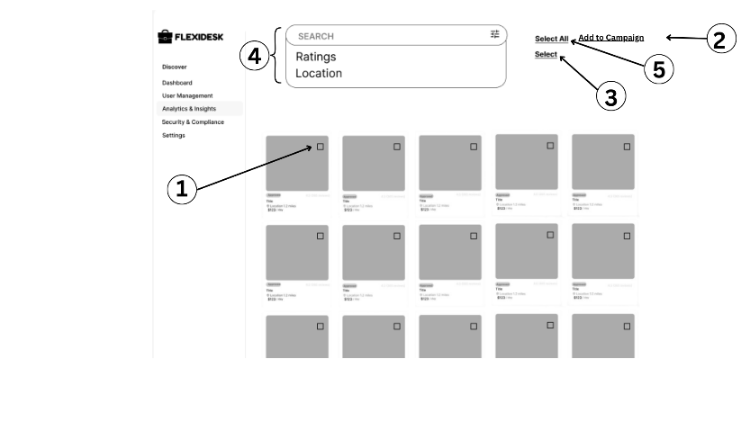

**Figure 68. Analytics and Insights Selecting Spaces**

1. **Checkbox**
2. **Select**
3. **Add to camping**
4. **Search with ratings and location**
5. **Select All**

Figure 69 below displays the "Security & Compliance" section of the admin dashboard. It shows "Normalization Scores" with indicators for "GOOD" (78%), "MED" (High), and "HIGH" (43%) (1). Sections for "Data Access Control" with a "Manage" button (3) and "Encryption Settings" with a "View Logs" button and a toggle (2, 4) are present. Below, "Dispute Cases" (7) are listed with columns for "ID," "Status" (with a dropdown showing "Pending" and "Resolved") (6), and "Breach Type" (5). A search bar is available to filter dispute cases.

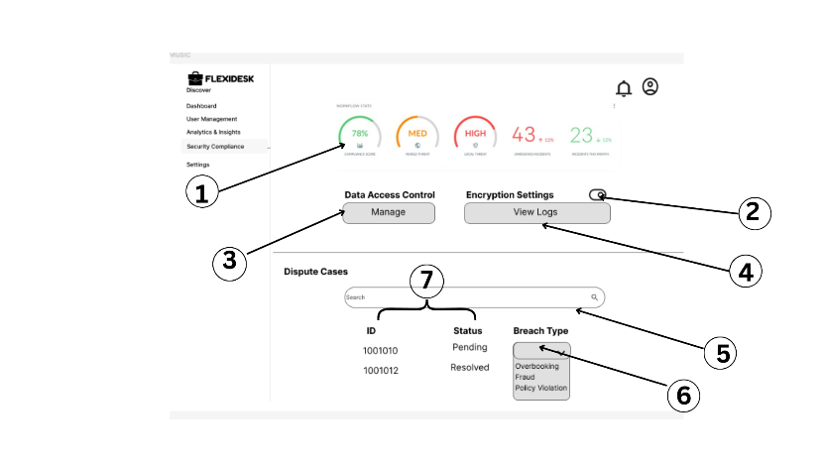

**Figure 69. Security Compliance**

1. **Security compliance rate**
2. **Encryption settings toggle**
3. **Manage buttons**
4. **View logs**
5. **Status of an Account with breach type drop down menu**

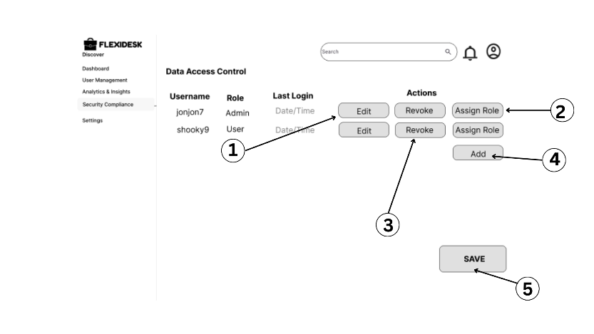 Figure 70 below shows the "Data Access Control" management interface. A table lists "Username," "Role" (e.g., Admin, User) (1), and "Last Login." For each user, "Actions" are available: "Edit," "Revoke" (access), and "Assign Role" (2, 3). An "Add" button (4) likely allows adding new users or roles. A "SAVE" button (5) is at the bottom.

**Figure 70. Data Access Control**

1. **Edit**
2. **Assign role**
3. **Revoke**
4. **Add**
5. **Save**

Figure 71 below displays the "Encryption Settings" logs. It shows columns for "Date," "User" (with a dropdown for filtering actions), "Action" (with options like "Login," "File Access," "Role Change" in a dropdown) (2), and "IP Address" (4). The navigation indicates "Security & Compliance > Encryption Settings > View Logs" (1). An "Export Logs" button (3) is available.

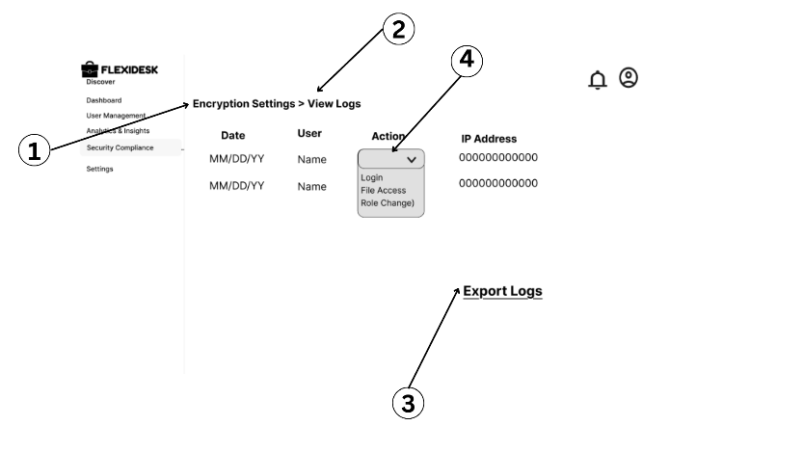

**Figure 71. View Logs**

1. **Encryption Settings Tab**
2. **View Log Tabs**
3. **Export Logs**
4. **Action Type Drop Down**

Figure 72 below shows the "Settings" section of the admin dashboard, specifically "Account Settings." Fields are available to edit "First Name" (1), "Email" (2), "Last Name" (3), "Phone Number" (4), and "Password" (5) with an "Enter" button (6). Options to "Deactivate" (7) the account or "Create new" (likely a new admin account) (8) are also present.

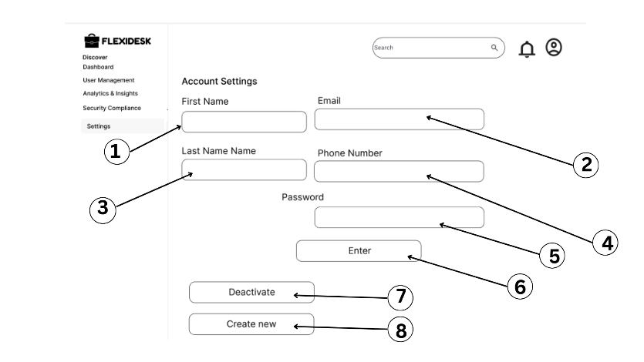

**Figure 72. Admin Account Settings**

1. **First name text box**
2. **Last name text box**
3. **Email text b box**
4. **Phone number box**
5. **Password**
6. **Enter button**
7. **Deactivate button**
8. **Creatie new button**

Figure 73 in the next page simply shows the "Notifications" section, with the heading "Notifications" and no actual notifications displayed (1).

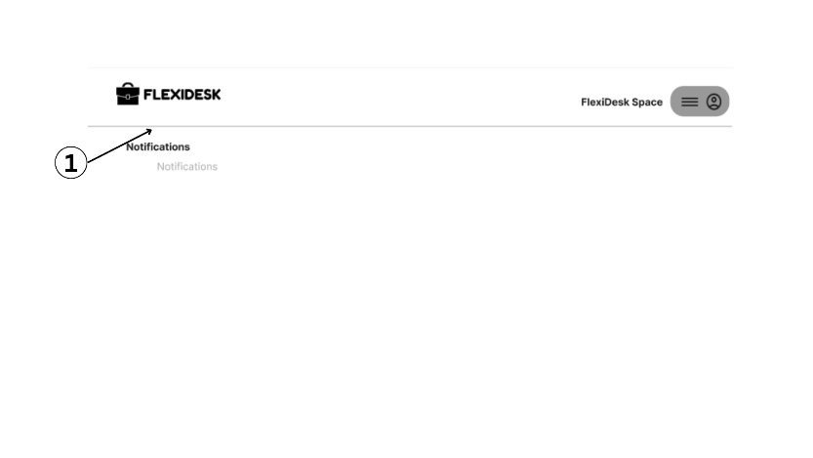

**Figure 73. Notifications**

1. **Notifications**

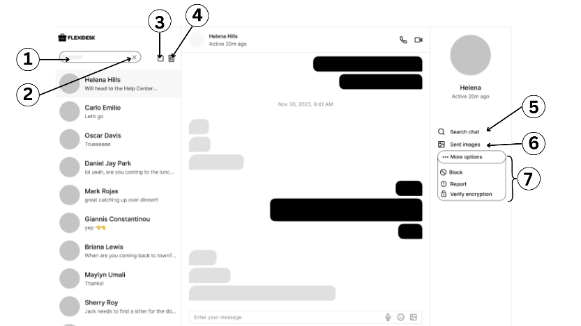 Figure 74 below displays a messaging interface within FlexiDesk. A search bar (1) and a list of contacts (2) are on the left, including "Helena Hills," "Carlo Emilio," etc. The main panel shows a conversation with "Helena Hills," indicating she was "Active 30m ago." Messages are displayed with timestamps. At the top right, options for video and phone calls are present (3, 4). On the right sidebar (5), contact information for Helena is shown, along with options to "Search chat," "Send images" (6), and "More options" (7) like "Block," "Report," and "Verify encryption." An input field for typing a new message is at the bottom.

**Figure 74. Messages**

1. **Search Bar**
2. **Close**
3. **Checkbox**
4. **Delete icon**
5. **Search chat bar**
6. **Images**
7. **More option drops down**

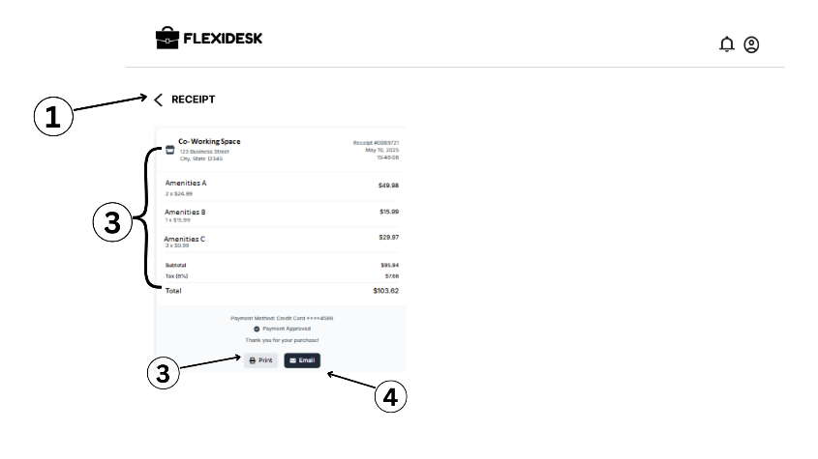 Figure 75 below presents a detailed digital receipt page on the FLEXIDESK platform, indicating a successfully completed transaction. The clear "< RECEIPT" header at the top left allows for easy navigation back. The main content of the receipt confirms the "Co-Working Space" booking, providing its full address, a unique receipt number, and the transaction date. A transparent, itemized breakdown of costs is provided, listing "Amenities A," "Amenities B," and "Amenities C" with their individual prices. This leads to a subtotal of P95.94, followed by an 8% tax of P7.68, resulting in a grand total of P103.62. The receipt clearly states "Payment Approved" and specifies the payment method as "Credit Card ****1149," accompanied by a "Thank you for your purchase!" message. For user convenience, options to "Print" a physical copy or "Email" the receipt are readily available.

**Figure 75. Receipt**

1. **Back Button**
2. **Price details**
3. **Print - can be save as pdf**
4. **Email - send via email**

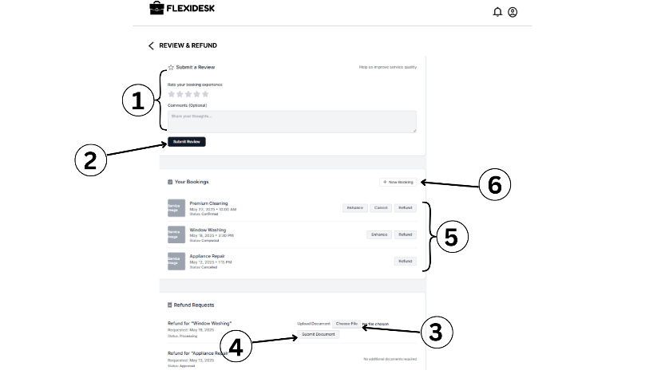 Figure 76 below This figure displays the "Review & Refund" page on the FLEXIDESK platform, serving as a comprehensive interface for customer feedback and booking management. Users are encouraged to "Submit a Review" for their booking experience, allowing them to provide a star rating and optional textual comments. Below this, a section titled "Your Bookings" lists past and upcoming services, such as "Premium Cleaning," "Window Washing," and "Appliance Repair," along with their respective dates. Each booking entry shows its current status and provides actionable buttons like "Enhance" and "Refund," enabling users to initiate a refund request for specific services. For refund requests requiring supporting documentation, a dedicated "Refund Requests" section provides functionality to "Choose File" and "Submit Document." A "New Booking" option is also available for initiating new reservations.

**Figure 76. Review and Refund**

1. **Review Section**
2. **Submit Review Button**
3. **Choose File Button**
4. **Submit Document Button**
5. **Bookings Status Buttons (Enhance, Cancel, Refund)**
6. **New Booking Button**

Figure 77 in the next page illustrates the "Access Your Booking" page within the FLEXIDESK platform, providing users with versatile methods for gaining entry to their reserved co-working space. The primary method displayed is through a "QR Code Preview" area, accompanied by a "Scan QR at Entrance" button, indicating the use of a scannable QR code for physical access. Alternatively, users can opt for a traditional password-based entry by inputting their unique "Booking ID" and "Password" into designated fields, followed by clicking the "Access Space" button. A "Forgot password?" link is conveniently provided for password recovery. Below these access options, a "Recent Bookings" section offers a historical overview of previous reservations. This list includes the "Space" name, the "Date" of the booking, its current "Status" and for active bookings, a direct "QR" button for immediate access to the corresponding QR code, significantly streamlining the entry process.

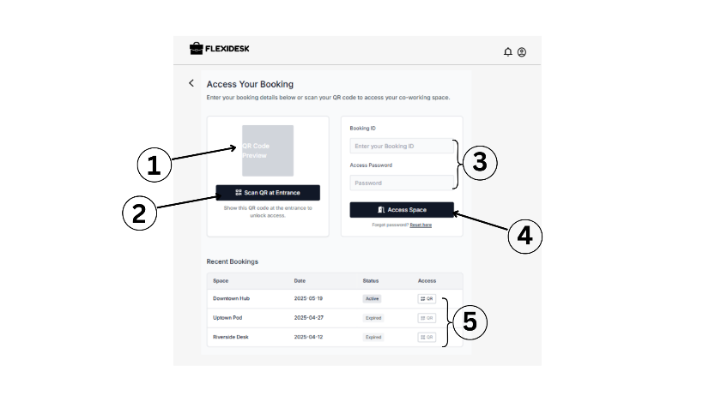

**Figure 77. Access your Booking**

1. **QR image**
2. **Scan qr button**
3. **Access Details**
4. **Access space button**
5. **QR button - to show the status**

Figure 78 in the next page depicts the "Notifications" page within the FLEXIDESK platform, serving as a centralized hub for all user-specific alerts and updates. The page clearly categorizes different types of notifications, such as "Get your promo" for promotional offers, "Queue Notifications" which likely relate to service queues or waiting lists, and "Co-Workplace Updates" for general announcements or changes pertinent to the co-working environment. When no new alerts are present, the message "No more notifications" is clearly displayed, providing a transparent view of the user's notification inbox. For managing these alerts, the interface includes basic controls on the right side, specifically a "Select" option to choose multiple notifications and a distinct icon that likely represents a "Delete" or "Archive" function, allowing users to efficiently organize and clear their notification 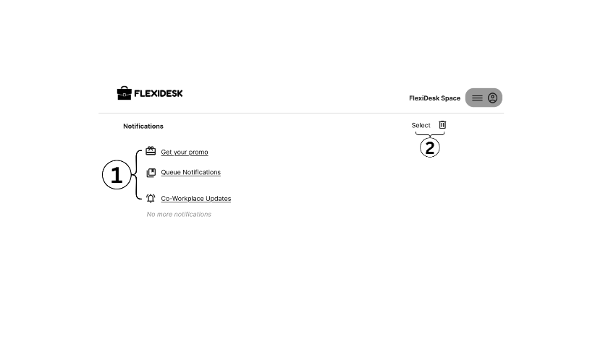history.

**Figure 78. Notifications**

1. **Notification links**
2. **Deleting Section - to delete notifications**

This figure presents the "Client Entry Control" page within the FLEXIDESK platform. The interface offers two distinct authentication methods: "QR Code Authentication," where a "QR Code Preview" is shown and a "Generate New QR Code" button allows for the creation of unique, scannable entry codes; and "Password-Based Access," which provides an input field to "Enter or generate a secure password" with a corresponding "Generate password" button. Below these access generation tools, a detailed list of "Booked Clients" for May 2025 is displayed, showcasing individual client names along with their respective booking dates and times. For each client, there are specific actions available: "Send QR" to digitally transmit the QR code for entry, and "Send Password" to provide password-based access credentials. Additionally, a "View Access Log" option is conveniently located at the top right

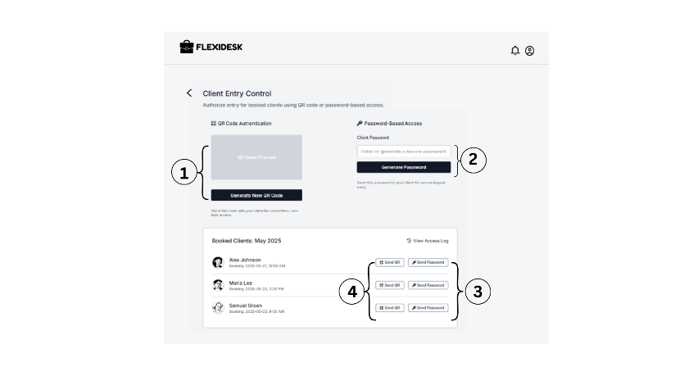

**Figure 79. Client Entry Control**

1. **QR code generator**
2. **Password Generator**
3. **Send password button**
4. **Send QR button**

Figure 80 below illustrates a dedicated section within the FLEXIDESK platform where hosts or administrators can define and configure the amenities and features offered by a co-working space. This page is likely an integral part of the space setup or profile management process, allowing owners to accurately represent their offerings. A clear selection of common co-working amenities is presented as clickable buttons, designed for easy selection. These include essential facilities such as "Computers," "Lockers," "Heating," "Air Conditioning," "EV Charger," "WiFi," "Free Parking," and "Multi-functional Printers." This structured list simplifies the process of detailing a space's offerings to potential users. Furthermore, an "Add" button is provided, indicating the flexibility for hosts to input and include any custom amenities or unique features that may not be pre-listed, allowing for a personalized and comprehensive space description. Once the desired amenities are selected, a prominent "Save" button is located in the top right corner, allowing the host to finalize and commit these configurations to their co-working space's public profile. A "BACK" link on the left side ensures easy navigation to previous steps in the setup workflow, promoting a user-friendly configuration experience.

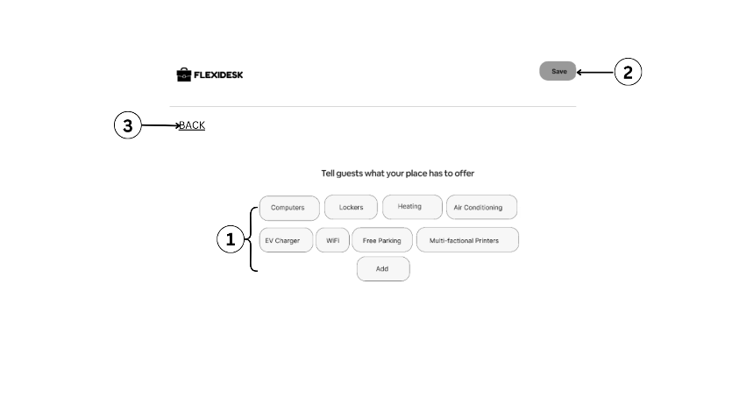

**Figure 80. Amenities to Offer**

1. **Amenities Selections - (can add another by owner)**
2. **Save button**
3. **Back button**

## **Hardware Requirements in Developing the System**

The hardware requirements for developing the system are carefully chosen to support a fast, stable, and efficient software development environment. To begin with, the system must run on an updated operating system—Windows 10 or later, or macOS Monterey or later. These platforms are widely supported by modern development tools, IDEs (Integrated Development Environments), and libraries necessary for web application development. A processor such as the Intel Core i5 (9th Generation or newer) or AMD Ryzen 5 or higher is ideal, as these CPUs offer sufficient power to compile code, run virtual environments, and manage demanding background processes without lag, all of which are critical in the software development cycle.

In addition to processing power, memory and storage play a major role in the efficiency of the development setup. A minimum of 8 GB of RAM is required, although 16 GB is highly recommended to ensure seamless multitasking—especially when working with heavy applications like code editors, graphic design tools, local servers, and emulators. For storage, a Solid State Drive (SSD) with at least 512 GB capacity is recommended. SSDs drastically improve file access speed, software installation times, and overall system responsiveness compared to traditional hard drives. This amount of storage also allows developers to maintain all essential tools, project files, and backups without concern for running out of space. Overall, meeting these hardware requirements will significantly improve development speed, reliability, and user experience throughout the creation of the system.

**Table 3.** **Hardware Requirements in Developing the System**

|  |  |
| --- | --- |
| **HARDWARE** | **SPECIFICATION** |
| Operating System | Windows 10 or later / macOS Monterey or later |
| CPU | Intel Core i5 (9th Gen or higher) / AMD Ryzen 5 or higher |
| RAM | Minimum 8 GB (16 GB recommended for multitasking and running emulators/tools) |
| Storage | At least 512 GB SSD (for fast file access and software builds) |

## **Hardware Requirements in Using the System**

The hardware requirements for using the system are designed to ensure that users can access and operate the FlexiDesk platform smoothly across various devices. The system supports a wide range of operating systems, including Windows 7 or later, Android 10 and above, iOS 13 and above, and macOS Mojave or newer. This cross-platform compatibility ensures that the application can be accessed on both desktop and mobile devices, making it convenient for clients and workspace owners alike. By allowing compatibility with slightly older operating systems, the system remains accessible to a broader audience without compromising functionality.

In terms of processing power, a dual-core processor or higher is sufficient for running the system efficiently, whether through a browser or a mobile app. The minimum recommended RAM is 4 GB, which is adequate for handling tasks such as browsing available workspaces, booking schedules, and processing payments without causing performance issues. Additionally, users should have at least 100 MB of free storage space to accommodate temporary files, cached data, or app installation, especially if accessing the platform via a mobile application. These specifications help guarantee a smooth user experience while keeping the system lightweight and accessible for everyday users.

**Table 4.** **Hardware Requirements in Using the System**

|  |  |
| --- | --- |
| **HARDWARE** | **SPECIFICATION** |
| Operating System | Windows 7 or later / Android 10+ / iOS 13+ / macOS Mojave+ |
| CPU | Dual-core processor or higher |
| RAM | Minimum 4 GB |
| Storage | At least 100 MB of free space (for temporary files/cache if web-based or app installation) |

## 

## **Software Requirements in Developing the System**

This section outlines the essential software tools and environments necessary for building FlexiDesk. The operating system requirements include Windows 10/11, macOS, or Linux (preferably Ubuntu 20.04+), ensuring compatibility across major development platforms. While the "Browser" field mistakenly lists a hardware specification ("Dual-core processor or higher"), it’s likely meant to refer to browsers like Chrome or Firefox, which are typically used during front-end testing. The programming languages used are JavaScript (with Node.js and React.js frameworks), HTML5, and CSS3, which support both dynamic front-end user interfaces and robust server-side functionality.

The database management system options include MongoDB for a NoSQL approach or MySQL for a relational database, depending on the structure and scalability requirements of the application. The development environment consists of Visual Studio Code, a powerful source code editor, along with tools like Postman for testing APIs and Git for version control and collaboration. These software components are critical in ensuring an efficient, maintainable, and scalable development process for FLEXIDESK. Together, they provide a modern web development stack capable of supporting the app’s real-time tracking and booking features.

**Table 5. Software Requirements in Developing the System**

|  |  |
| --- | --- |
| **SOFTWARE** | **SPECIFICATION** |
| Operating System | Windows 10/11, macOS, or Linux (Ubuntu 20.04+) |
| Browser | Dual-core processor or higher |
| Programming Language | JavaScript (Node.js, React.js), HTML5, CSS3 |
| Database Management | MongoDB or MySQL (depending on relational or NoSQL preference) |
| Environment | Visual Studio Code, Postman (API testing), Git (version control) |

## **Software Requirements in Using the System**

The system is designed to be web-based and fully responsive, meaning it can be accessed through any modern internet browser without requiring additional installations or plugins.

Specifically, the application supports widely used browsers such as Google Chrome, Mozilla Firefox, Safari, and Microsoft Edge. These browsers are chosen for their compliance with modern web standards, high performance, and broad user base, ensuring a smooth and consistent user experience. By relying on these mainstream browsers, FLEXIDESK guarantees compatibility across different devices and platforms, allowing users to conveniently book and track co-working spaces from desktops, laptops, tablets, or smartphones.

**Table 6. Software Requirements in Using the System**

|  |  |
| --- | --- |
| **SOFTWARE** | **SPECIFICATION** |
| Browser | Google Chrome, Mozilla Firefox, Safari, or Microsoft Edge |

## **Testing and Evaluation**

The development of FlexiDesk, a smart web application designed for tracking and booking co-workspace environments, meets the needs and expectations of its intended users, a comprehensive testing and evaluation process will be implemented. This evaluation will utilize the ISO/IEC 25010:2011 software quality assessment framework, which provides a robust and standardized structure for assessing software sustainability and quality. The evaluation will focus on four key quality characteristics: functionality, efficiency, usability, and reliability. These dimensions are essential in determining whether the system delivers an effective, seamless, and dependable experience for individuals and organizations booking and managing co-working spaces.

Functionality will be assessed to determine whether FlexiDesk fulfills its intended purpose and incorporates all critical features of the platform. Specifically, the evaluation will verify whether functions such as workspace availability tracking, real-time booking, reservation management, user account management, and notification services operate as designed and meet the practical needs of users. Efficiency will measure the speed and responsiveness of the system in executing core operations, such as searching for available workspaces, completing bookings, and managing reservations. The evaluation will also consider how efficiently the application uses system resources under normal and peak usage conditions to ensure optimal performance without unnecessary delays or bottlenecks.

Given the varied levels of computer literacy and technical familiarity among users, usability will be a crucial focus. This aspect of the evaluation will examine how intuitive and user-friendly FlexiDesk is by assessing ease of navigation, clarity of the interface design, accessibility of features, and overall user satisfaction. The goal is to ensure that both novice and experienced users can utilize the application effectively without requiring extensive guidance. Reliability will evaluate the stability of the system under different operating conditions. This will include assessing fault tolerance, the system’s capacity to recover from unexpected failures, and its ability to maintain consistent performance over time without data loss or service disruptions. Special attention will be given to safeguarding user data and reservations, ensuring they remain intact even during unforeseen system interruptions.

**Table 7****. Likert Scale**

|  |  |
| --- | --- |
| **SCALE** | **VERBAL INTERPRETATION** |
| 5 | Strongly Agree |
| 4 | Agree |
| 3 | Somewhat Agree |
| 2 | Disagree |
| 1 | Strongly Disagree |

To collect user feedback for the evaluation, a structured survey questionnaire will be administered after participants interact with the application. The survey will feature statements aligned with the four quality characteristics and will ask respondents to indicate their level of agreement using a five-point Likert scale. This scale will consist of the following values: 5 for "Strongly Agree," 4 for "Agree," 3 for "Somewhat Agree," 2 for "Disagree," and 1 for "Strongly Disagree." The gathered responses will be analyzed by calculating the weighted mean for each quality attribute. The resulting scores will be interpreted based on predefined ranges: a weighted mean between 4.20 and 5.00 will indicate "Strongly Agree"; 3.40 to 4.19 will represent "Agree"; 2.60 to 3.39 will correspond to "Somewhat Agree"; 1.80 to 2.59 will signify "Disagree"; and 1.00 to 1.79 will denote "Strongly Disagree."

**Table 8. Range of Verbal Interpretation**

|  |  |
| --- | --- |
| **MEAN RANGE** | **VERBAL INTERPRETATION** |
| 4.20 - 5.00 | Strongly Agree |
| 3.40 - 4.19 | Agree |
| 2.60 - 3.39 | Somewhat Agree |
| 1.80 - 2.59 | Disagree |
| 1.00 - 1.79 | Strongly Disagree |

This systematic testing and evaluation process aims to provide an objective and comprehensive assessment of FlexiDesk’s quality, sustainability, and readiness for deployment. By aligning the assessment with the internationally recognized ISO/IEC 25010:2011 framework and gathering direct feedback from users, the proponents seek to ensure that FlexiDesk emerges as a reliable, efficient, and user-centric solution capable of supporting the dynamic needs of co-working space users and administrators, both for present operations and future scalability.

## **Test Case**

Test cases serve as evaluative tools to determine whether "FlexiDesk: A Smart Web Application for Tracking and Booking Co-Workspace Environment" meets the functional, usability, and performance expectations of its primary users, which include students, remote professionals, freelancers, and business organizations. Each test case is designed to assess critical system functions such as user registration, workspace search and booking, digital payments, smart access, and interactive features like in-app messaging and reviews.

The purpose of these test cases is to simulate real-world user scenarios and collect meaningful feedback during the testing phase. This helps guide improvements to ensure that the system provides a seamless, secure, and efficient workspace booking experience.

The evaluation of each test outcome is overseen by the development or QA team, with success determined by how well the system delivers ease of use, reliability, responsiveness, and satisfaction across devices and transaction flows. The system is considered effective if it fulfills its core objectives and provides a user experience that aligns with expectations established during the design and planning stages.

Table 7 outlines the user test cases for FlexiDesk, focusing on critical aspects such as search accuracy, booking efficiency, secure payments, responsive design, and interactive features. Each test case is documented with its description, expected outcome, actual outcome, and final status to ensure comprehensive evaluation.

Table 9. Sample Test Case for User

|  |  |  |  |  |
| --- | --- | --- | --- | --- |
| **Task**  **ID** | **TASK DESCRIPTION** | **EXPECTED RESULTS** | **ACTUAL RESULTS** | **Status** |
| **1** | Ensure that users can search for available workspaces by location, amenities, and date | Users should be able to filter and view a list of available workspaces matching their criteria |  |  |
| **2** | Verify that users can view workspace details before booking | Users should see complete details including images, amenities, pricing, and availability |  |  |
| **3** | Ensure that users can book a workspace and receive booking confirmation | Upon selecting a date and time, booking should be processed, and confirmation with receipt should be sent |  |  |
| **4** | Verify that users can pay through digital wallets (e.g., GCash or PayPal) | Payment should be processed, and receipt generated upon successful transaction |  |  |
| **5** | Verify that users can access the workspace using QR code after booking | The system should generate a QR code that allows entry during the booking period |  |  |
| **6** | Verify that users can add workspaces to favorites and receive update notifications | User should be able to favorite listings and get alerts for promotions or changes |  |  |
| **7** | Ensure that users can cancel a booking according to the cancellation policy | System should allow users to cancel and provide refund options based on criteria |  |  |
| **8** | Verify in-app chat functionality with workspace providers | Users should be able to communicate in real time for inquiries or concerns |  |  |
| **9** | Confirm that users can leave reviews and ratings after using the space | After a completed booking, the review option should be available |  |  |
| **10** | Test system’s responsiveness on multiple devices | The layout and features should work smoothly on desktop, tablet, and mobile |  |  |

Table 8 presents a structured summary of the test cases developed to assess the core administrative functionalities within the FlexiDesk: A Smart Web Application for Tracking and Booking Co-Workspace Environment system. These test cases were specifically designed to evaluate the admin’s capabilities in managing platform operations, ensuring user and workspace verification, resolving conflicts, overseeing secure transactions, and monitoring platform activity. The FlexiDesk admin role is central to maintaining the integrity, security, and efficiency of the workspace booking environment.

The test cases cover essential administrative tasks such as verifying workspace listings, monitoring user activity, flagging suspicious behavior, managing disputes and refunds, and promoting high-demand listings. The system also equips admins with tools for analytics and reporting, enabling data-driven decisions regarding usage trends, revenue flow, and system engagement. Additional capabilities such as posting platform-wide announcements, approving or suspending users, and enforcing compliance policies were also evaluated.

Testing was conducted by a three-member team, composed of one administrator, one system analyst, and one QA developers, to ensure a multi-perspective approach. Each test case was evaluated for functionality, usability, responsiveness, and security. The goal was to confirm that all admin features work seamlessly, providing administrators with the control and visibility needed to support a smart, scalable co-working platform.

This testing effort ensures that FlexiDesk not only meets its operational goals but also provides a dependable management environment aligned with real-world administrative workflows in co-working management systems.

Table 10. Sample Test Case for Admin

|  |  |  |  |  |
| --- | --- | --- | --- | --- |
| **Task**  **ID** | **TASK DESCRIPTION** | **EXPECTED RESULTS** | **ACTUAL RESULTS** | **Status** |
| **1** | Confirm that admin can detect and flag suspicious or fraudulent bookings | Admin should successfully access the admin dashboard |  |  |
| **2** | Verify that admin can manage user accounts (activate, deactivate, suspend) | Admin should be able to review details, documents, and approve or reject listings |  |  |
| **3** | Test admin’s ability to view analytics reports (occupancy, revenue, trends) | The system should allow admin to mark and investigate flagged transactions |  |  |
| **4** | Ensure that admin can respond to disputes and refund requests | Admin should be able to update user status and restrict access if necessary |  |  |
| **5** | Confirm that admin can highlight featured listings on the homepage | Analytics dashboard should display accurate data and visual reports |  |  |
| **6** | Verify that admin can send announcements or promotions to all users | Admin should view requests, approve/refuse refunds, and message users if needed |  |  |
| **7** | Ensure that admin can view user and workspace ratings and feedback | Admin should mark listings as “Featured” and they should appear prominently to users |  |  |
| **8** | Validate that admin can manage data privacy settings and security protocols | System should deliver announcements through email or in-app notifications |  |  |
| **9** | Confirm that admin can detect and flag suspicious or fraudulent bookings | Feedback and ratings should be accessible for review and moderation |  |  |
| **10** | Verify that admin can manage user accounts (activate, deactivate, suspend) | Admin should configure access roles, encryption policies, and audit logs |  |  |

**System Evaluation**

In assessing the FlexiDesk system in accordance with the ISO/IEC 25010:2011 quality model, the evaluation focused on four key software quality attributes: functionality, efficiency, usability, and reliability. The system is designed to perform optimally within these criteria while addressing the needs of workspace users, space owners, and administrators.

In terms of functionality, FlexiDesk is expected to deliver a comprehensive and user-friendly platform for workspace search, booking, and management. Users such as students, freelancers, and organizations should be able to browse available spaces, filter by location or amenities, book instantly, and process secure payments—all within a single platform. Key features like AI-driven recommendations, QR code access, and in-app communication ensure the system caters to diverse user requirements. Moreover, workspace owners can manage listings, monitor earnings, and implement smart pricing strategies. The admin panel supports verification processes, data analytics, and system security management. These features collectively ensure that FlexiDesk performs tasks accurately and meets stakeholder expectations.

Regarding efficiency, the system is designed for fast performance and minimal latency, allowing users to navigate seamlessly across different modules—from searching for workspaces to completing bookings. The system architecture supports concurrent access, ensuring performance remains stable during peak usage. Real-time calendar syncing, automated confirmations, and instant notifications are optimized to reduce processing delays and enhance user interaction, making workspace booking more time-efficient and less cumbersome.

For usability, FlexiDesk features a clean, intuitive user interface that allows both tech-savvy and non-technical users to access its functionalities with ease. The layout is designed for clarity, with easy-to-navigate menus, smart search filters, and responsive design for mobile and desktop platforms. Customizable dashboards, notification settings, and AI-based suggestions enhance the user experience further. New users should require minimal guidance, while returning users benefit from personalization features that adapt to their behavior and preferences.

In terms of reliability, FlexiDesk is built to ensure continuous availability and accurate transaction handling. The system maintains data integrity during bookings, payments, and user profile management, reducing the risk of errors or double bookings. It incorporates robust backup, error-handling, and recovery mechanisms to minimize downtime in case of system issues. AI-powered fraud detection and secure login protocols strengthen trust and dependability for all users. The platform is expected to operate consistently even under high load, ensuring uninterrupted access and stable performance.

**Schedule and Timeline**

The development of the system followed a structured timeline to ensure that all tasks were completed efficiently and on schedule. The process began in January, where the team initiated the brainstorming phase, generating ideas and selecting the most viable system concept. Once the idea was finalized, they moved on to creating the TAF in February, which was then submitted for adviser and chairperson approval, a process that continued into March.

With the TAF approved, the group immediately began writing Chapter 1 and submitted it for revision, also completed in March. As April started, the proponents proceeded with the creation of Chapter 2, followed by its submission and revision. During this same month, they also began developing Chapter 3.

By May, Chapter 3 was submitted and reviewed, and adviser feedback was received for all initial chapters. With this foundation, the team prepared for and conducted their Pre-Oral Defense. Entering June, they focused on writing Chapter 4 and Chapter 5, which were then submitted for review and revision in July, along with a second round of adviser feedback.

The coding and system development phase officially began in August, as the team translated their plans and requirements into a functional system. Development continued into September, during which testing also began to ensure system stability and functionality. Finally, by October, the project moved into its final stages with system deployment and preparation for the Final System Defense. This structured and well-distributed timeline allowed the group to manage their tasks effectively while incorporating feedback and making necessary improvements throughout the journey.

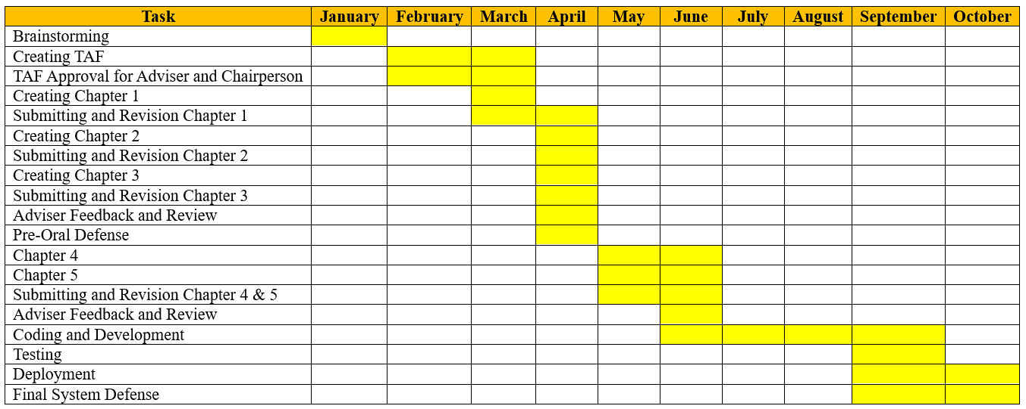**Table 11. Gantt Chart**

**Project Teams and their Responsibilities**

Each member of the project team was assigned a specific role, ensuring that the workload was effectively distributed and that each task contributed meaningfully to the successful development and completion of the project. Clear communication and strong collaboration among the members were essential in maintaining workflow efficiency and achieving the project’s objectives.

Ms. Jonalyn Umali, serving as the Project Manager, was responsible for overseeing the overall progress and direction of the project. She managed the planning, organizing, and scheduling of tasks to ensure that deadlines were met and milestones were achieved. Jonalyn also facilitated coordination among the team members, handled decision-making processes, and ensured the project stayed aligned with its goals and timeline. Her leadership was key to maintaining a focused and productive environment.

Mr. John Michael Macaisa, the Developer/Programmer, took charge of the technical aspects of the system. He was responsible for coding and implementing the core functionalities of the platform. From front-end to back-end development, he ensured that the system operated smoothly and efficiently. He also collaborated closely with the team to integrate feedback and resolve technical issues, playing a crucial role in bringing the project’s design and requirements to life.

Mr. Axel Gerard Mondalo, acting as the Documenter, handled the preparation and organization of all project documentation. His responsibilities included compiling research findings, system requirements, progress reports, and final output documentation. He ensured that all project details were clearly and systematically recorded, providing a comprehensive reference that reflected the system’s development process from start to finish.

**Table 12. Budget Cost Management Plan**

|  |  |  |
| --- | --- | --- |
| **Activity** | **Estimated Cost** | **Purpose** |
| Domain and Hosting | 1500 | For hosting the web-based FlexiDesk platform |
| Transportation | 1200 | Travel to meet up with groupmates, consultation with adviser and survey |
| Printing | 3000 | For printing capstone manuscript |
| Internet/Load Allowance | 1000 | For research, communication, and online system testing |
| Pre-Oral Defense | 1850 | For pre-oral defense panel list |
| AI Azure Fraud Subscription | 1000 | For fraud ai detector |
| Token for Adviser | 500 | For giving token for adviser |
| Web and Application Subsctiption | 1000 | For using any application or website to subscribe |
| Book Binding and CD | 2500 | For completion |







**BIBLIOGRAPHY**

[1] Sood, T., Janssen, P., & Miller, C. (2020). Spacematch: Using Environmental Preferences to Match Occupants to Suitable Activity-Based Workspaces. arXiv preprint arXiv:2006.09570.

[2] Murad, N.H.I. (2022). What Drives Collaboration Among Filipino Freelancers? Assessing the Physical and Social Elements of Coworking Spaces. https://www.researchgate.net/publication/348306558_What_Drives_Collaboration_Among_Filipino_Freelancers_Assessing_the_Physical_and_Social_Elements_of_Coworking_Spaces

[3] Atienza, Ingrid Marie N. (2022). Perceptions of selected young-adult filipinos on coworking spaces for hybridoperations. https://digitalarchives.upd.edu.ph/item/56121?fbclid=IwZXh0bgNhZW0CMTEAAR4ym1pHk0CKL tplVA9ev_FyolATrOyCUoiJkdkcMGjUBFfg71n-OoRkm3unGg_aem_VHAL-- 7T73u46QWRx_b6fA

[4] Coworking in the Philippines: Emerging spaces in Manila: 2024. https://mspacesph.com/blog/coworking-philippines/?fbclid=IwZXh0bgNhZW0CMTEAAR7gRj9YcDh16g7MGOcGzus6hPlRitc31CpdiidlfO2zLRRXiYOMQJDlA5rFqQ_aem_dj5G6c0cO2DqaXQbLzktEg.

[5] The Report: Philippines 2021 - Oxford Business Group The Report: Philippines 2021 OBG: 2023. https://oxfordbusinessgroup.com/reports/philippines/2021-report.

[6] Abun, Damianus, (2021). The Effect of Workplace Relationship toward Job Satisfaction of Divine Word Colleges’ Employees in Region I, Philippines. Available at SSRN: https://ssrn.com/abstract=3807897 or http://dx.doi.org/10.2139/ssrn.3807897

[7] Mátyus, E. 2021. Digitalization of coworking space services. Proceedings of the International Conference on Business Excellence. 15, 1 (Dec. 2021), 1060–1068. DOI:https://doi.org/10.2478/picbe-2021-0100.

[8]Reyes, Rizal Raoul. (2024). Flexible working space continues to grow. https://businessmirror.com.ph/2024/09/04/flexible-working-space-continues-to-grow/

[9]Coworking Spaces in the Philippines: Market Trends and Opportunities in 2023: 2023. https://salesrain.com/2023-market-trends-for-coworking-spaces-in-the-philippines

[10]Cameron, Roché . Determinants of coworking space user needs to optimise user performance: 2024. https://repository.up.ac.za/handle/2263/96424.

[11]Sood, T., Janssen, P. and Miller, C. 2020. Spacematch: Using Environmental Preferences to Match Occupants to Suitable Activity-Based Workspaces. Frontiers in Built Environment</i>. 6, (Jul. 2020). DOI:https://doi.org/10.3389/FBUIL.2020.00113

[12]Balmes, I.L., Alejandro, R.M.P., Gamo, J.M.L. and Ilagan, A.M.T. 2022. PARADA: Parking Space Rental and Leasing Application System. Computing and Communication Workshop and Conference. (Jan. 2022), 0851–0856. DOI:https://doi.org/10.1109/CCWC54503.2022.9720838.

[13]Golo, M.A.T. and Encarnacion, R.E. 2024. Revolutionizing the Rental Services in Siargao Island: Basis for Developing an Online Vehicle Rental Management System. International Journal of Advanced Research in Science, Communication and Technology. (Jun. 2024), 438–447. DOI:https://doi.org/10.48175/ijarsct-18754.

[14]German, J. D., Yap, D. C. G., & Binoya, G. O. (2021). Design and Development of an Integrated Room Reservation System for Higher Education Institutions. Conference on Industrial Electronics and Applications, 231–236. https://doi.org/10.1109/ICIEA52957.2021.9436766

[15]German, J. D., Bautista, S. L. S., Bonagua, P. A. R., Chan, C. V. L., Mallen, J. E. L., & Plantilla, F. C. B. (2024). Appoint Deportes: An Online Reservation System for Sports Facilities. 206–211. https://doi.org/10.1145/3647782.3647814

[16]Leona, R. F., Manantan, K. K. M., Puzon, J. M. D., Guiling, J. L. A., Nelmida, C. J. V., Espiritu, B. P., & Olipas, C. N. P. (2023). Development and Assessment of AppStay: A Web-Based Room, Dorm and Apartment Reservation System. Path of Science. https://doi.org/10.22178/pos.95-16

[17]Gosela, R.R.U. and Encarnacion, R.E. 2024. Booking and Reservation System: A Unified Application Using Location-Based Services for Sustainable Tourism Networks. International Journal of Advanced Research in Science, Communication and Technology. (Jun. 2024), 739–749. DOI:https://doi.org/10.48175/ijarsct-18889.

[18]Reyna, A.C.C. 2023. Development and Implementation of a Web-Based PUV Booking App. International Journal of Advanced Research in Science, Communication and Technology. (Jul. 2023), 562–568. DOI:https://doi.org/10.48175/ijarsct-12179.

[19]Hutke, A., Bhosale, B., Daggula, M., Pawar, V. and Shaikh, S. 2024. BOOKEAZY - Book Your Appointments with Ease. International Journal For Science Technology And Engineering. 12, 4 (Apr. 2024), 5712–5719. DOI:https://doi.org/10.22214/ijraset.2024.61337

[20]Shibghatullah, A. S., Jalil, A., Abd Wahab, M. H., Ng Poh Soon, J., Subaramaniam, K., and Eldabi, T. 2022. A Vehicle Tracking Application with Improved ETA Accuracy Using GPS and Google Distance Matrix API. International Journal of Electrical and Electronic Engineering & Telecommunications, 11, 1 (2022), 67–73. DOI: https://doi.org/10.18178/ijeetc.11.1.67-73